### Monetary Policy after the Fall

by

Charles Bean, Matthias Paustian, Adrian Penalver and Tim Taylor *

Federal Reserve Bank of Kansas City Annual Conference Jackson Hole, Wyoming

28 August 2010

*Bank of England. The assistance of Alina Barnett, Lavan Mahadeva, Clare Macallan, Haroon Mumtaz and Ryland Thomas was invaluable. Helpful comments and suggestions from Ed Nelson and numerous Bank of England colleagues are also gratefully acknowledged. The views expressed do not necessarily reflect those of either the Bank of England or the Monetary Policy Committee.

### Abstract

This paper draws some lessons from the crisis for the future conduct of monetary policy.

(1) We argue that while relatively low policy rates compared to past experience contributed to the growth in credit and the rise in house prices in the run-up to the crisis, they played only a modest direct role. But the reduction in volatility associated with the Great Moderation, some of which is likely to have been down to improved policy making, also appears to have had an effect. (2) Central banks have deployed a range of unorthodox policies during the crisis. Those that support particular markets, sectors or firms have no place in normal times. Asset purchases designed to lower longer-term yields and boost asset prices more generally appear to have had some success but a short-term interest rate policy instrument represents a preferable monetary instrument in normal times. (3) The case for raising target inflation rates is unpersuasive, while the gains from moving to price-level targeting appear likely to be modest. (4) The case for “leaning against the wind” by raising policy rates higher than required to meet immediate inflation and output objectives appears strengthened by recent events, but the collateral damage to output from a policy that is sufficiently aggressive to make enough of a difference to credit conditions and asset prices is likely to be quite high. Development and deployment of a macro-prudential policy toolkit focussed more directly on the underlying source of the exuberance looks a more promising way forward.

### Introduction: The Consensus before the Crisis

The Great Financial Crisis that began in August 2007 and the associated Great Contraction in global economic activity that took place after the collapse of Lehman Brothers in September 2008 have presented central bankers and finance ministers in the advanced economies with one of the toughest challenges that they are ever likely to face. While no-one can claim to have done it perfectly, by dint of aggressive, and in many cases innovative, policy actions they have collectively succeeded in preventing the collapse of financial markets, arresting the contraction in activity and putting their economies on the path to recovery. Even so, the de- leveraging process is incomplete, the recovery remains fragile and a considerable margin of spare capacity is yet to be worked off, while further policy action may yet be necessary to keep the recovery on track. It may therefore seem premature to draw lessons from the crisis for the future conduct of monetary policy in normal times. But normal times will surely return in due course. And it is natural to ask whether the events of the past three years point to fundamental flaws in our policy frameworks.

The crisis was perhaps all the more remarkable because it occurred after such a long period of relatively steady growth and low and stable inflation – the Great Moderation. While the causes of the Great Moderation are open to debate, most policy makers probably put some of that improved macroeconomic performance down to better policy. That was reflected in a consensus – at least in the Anglo-Saxon world – as to the ingredients of a successful policy framework and was mirrored in an equivalent consensus in the academic literature on monetary policy, synthesising the rigour of dynamic general equilibrium modelling with the empirical realism of sticky-price Keynesian thinking, best exemplified in the magisterial contribution of Woodford (2003).

This pre-crisis set of beliefs was reflected in many of the contributions to this annual conference in the years leading up to the crisis and so might aptly be christened the “Jackson Hole” consensus; the volume *New Challenges for Monetary Policy* from the conference that took place here eleven years ago represents as good a reflection as any of that paradigm.

Broadly speaking, this Jackson Hole consensus consisted of the following ingredients:

* 1. Automatic stabilisers aside, fiscal policy was unsuitable as an instrument of macroeconomic demand management. That was justified theoretically by appeal to the comparative advantage of monetary over fiscal policy in controlling nominal demand or to Ricardian Equivalence or to the argument that fiscal expansions were harder to reverse than initiate.
  2. Monetary policy was therefore assigned the primary role in short-term aggregate demand management, with policy conducted through the manipulation of a suitable short-run interest rate.
  3. The monetary transmission mechanism operated mainly through longer-term interest rates, asset prices and expectations of future inflation. Expectations of future policy rates were central and credibility was key. These channels might be augmented by a weak credit channel but the banking sector generally was conspicuous by its absence, particularly in the New Keynesian synthesis models, which also dominated thinking within central banks. The importance accorded to expectations led naturally to an increased focus on communication and transparency.
  4. The conduct of monetary policy was best delegated to an independent central bank, free of short-term political considerations. That was buttressed by academic thinking which drew attention to the potential time inconsistency of optimal policy when expectations of future policy mattered and which suggested that monetary policy was best delegated to conservative central bankers with long horizons.
  5. Intermediate monetary targets were not useful, because of their unstable link with the ultimate objectives of policy (though that did not preclude them being helpful at times as indicators of future demand and inflation). For jurisdictions with floating exchange rates, monetary policy should instead be focussed on the only thing it could reliably determine in the long run, namely the price level. In many countries, this was codified into an explicit numerical inflation target; in others, the objective was left somewhat fuzzier. Focusing policy on the ultimate objective of price stability, rather than some intermediate variable, offered a policy framework that was both clearer to the public and potentially more durable. But the short-run stickiness of wages and

prices, coupled with the desirability of avoiding excessive fluctuations in activity, meant that some “constrained discretion” in the pursuit of price stability was appropriate; this flexibility was usually incorporated explicitly into central bank mandates in one way or another.

* 1. Asset markets were thought to be efficient at distributing and pricing risk and financial innovations were normally welfare enhancing. While asset prices might be subject to bouts of “exuberance” on the part of investors, there was little that monetary policy could do about them. The best monetary policy could was to limit the fallout when sentiment turned.
  2. Systemic financial crises were seen only in history books and emerging markets; they were unlikely to happen in advanced economies with their developed and well- regulated financial markets. Moreover, price stability and financial stability were natural bedfellows, the successful achievement of one facilitating the attainment of the other.

Of course, agreement with each and every element of this consensus was not universal. The European Central Bank, for instance, continued to place great value on the usefulness of a monetary pillar. And, as discussed below, there were some who believed that central banks should also use their constrained discretion to lean against incipient asset-price bubbles and credit growth. But the set of beliefs above were, we believe, held sufficiently widely in policy-making and academic circles to be described as a consensus.

In the rest of this paper, we re-visit some aspects of this consensus in the light of the crisis. It is not possible to cover all the elements of the consensus, though we shall offer some more wide-ranging observations at the end. In particular, we focus on: whether the experience with unorthodox policies during the crisis has changed our view of the appropriate policy instruments in normal times; whether the target rate of inflation should be increased or a shift

to price-level targeting is warranted; and what the experience of the crisis has taught us about how monetary policy should respond to credit/asset-price booms1. As a precursor to that discussion, however, we ask whether monetary policy decisions contributed materially to the crisis.

### Monetary Policy and the Crisis

It is worth stressing at the outset that a multitude of factors, both microeconomic and macroeconomic, played into the crisis. A non-exhaustive list of microeconomic factors includes: the incentive to shift loans off banks’ balance sheets to avoid capital requirements; the reduced incentive for care in the origination of loans, when those loans are then securitised; the distorted incentives facing ratings agencies; pay packages encouraging the pursuit of short-term returns and the adoption of trading positions with the characteristic of a deeply out-of-the-money option; and the moral hazard arising from financial institutions that are too big or too systemically important to fail, together with inadequate supervision of the same. On top of that, the crisis exposed previously unappreciated informational deficiencies created by the underlying complexity of some asset-backed securities and the high degree of interconnectedness of financial institutions. Potential macroeconomic factors include the international payments imbalances, and the side effects of the Great Moderation, as well as monetary policy. In our view, it would be a mistake to assign a key role to any of these factors in isolation. On their own, none can surely explain the worst financial crisis in eighty years. But together they constituted a potent cocktail. Monetary policy makers would therefore be remiss if they did not re-examine their own decisions in the lead-up to the crisis and strive to learn the lessons for the future conduct of policy.

In the normal course of events, looser monetary policy boosts asset prices, as lower policy rates are usually associated with somewhat lower longer-term interest rates too.

Expansionary policy can also be expected to boost activity and profits, which also tends to raise asset prices. But the case for monetary policy having a role in the run-up to the crisis

1 Some of these themes already figured in the contributions to the conference held here eleven years ago.

comes less from these conventional monetary transmission channels and more from the idea that loose monetary policy particularly encouraged a shift into riskier asset classes, which then got out of hand – the so-called “risk-taking channel” of monetary policy (Borio and Zhu, 2008).

There are broadly three ways in which looser monetary policy encourages increased risk- taking. First, and most conventionally, a lower yield on safe assets encourages substitution into higher-yielding risky assets, in the process driving up their prices. Second, some investors such as pension funds need to match the returns on their investments to their commitments. A reduction in the return on safe assets then encourages them to switch into high-yielding but riskier assets in an attempt to deliver nominal returns which match their liabilities – a “search for yield” (Rajan, 2005). Executive compensation linked to absolute returns has a similar effect.

Finally, a slightly more complex mechanism is developed by Adrian and Shin (2009) and Adrian, Moench and Shin (2010). They argue that financial intermediaries target leverage ratios which are either constant (commercial banks) or pro-cyclical (investment banks).

Consequently an increase in the value of a bank’s equity resulting from, say, a rise in the value of its (risky) assets will lead it to expand its debt (through deposit or wholesale funding) and a corresponding increase in its assets, either through extending new loans or acquiring additional securities. So as looser monetary policy boosts asset prices, it encourages an expansion in banks’ balance sheets, putting further upward pressure on asset prices. Leverage targets therefore act as an amplification mechanism. But the number of relatively safe borrowers/projects is limited. So the extension in the volume of loans is also likely to involve moving along the risk spectrum towards more risky borrowers.

Looser monetary policy is not the only factor operating through these channels. Two other macroeconomic factors are potentially relevant. First, a number of authors have focussed on the role of international payments flows in the crisis, with capital flowing “uphill” from emerging economies, such as China, into the United States and some other advanced economies (see, for instance, Obstfeld and Rogoff, 2009, and the references therein).

Bernanke (2005) attributes this to a “savings glut” in the surplus countries. Possible drivers include: an inadequate household safety net and restricted capital market access for

enterprises in China; the accumulation of precautionary holdings of international reserves by emerging economies following the Asia crisis; and rational savings of the windfall gains from higher oil prices on the part of oil producers. A perceived comparative advantage of the United States in creating “high quality” financial assets from real investments may also have played a part (Caballero, Farhi and Gourinchas, 2008). This resulted in downward pressure on the yields on government bonds and other safe assets, and upward pressure on asset prices generally. Low long-term safe interest rates would also have encouraged the shift into riskier assets through the risk-taking channel described above.

Second, the lead-up to the crisis was also a long period of steady growth coupled with low and stable inflation (the Great Moderation)2. Households, businesses and market participants were consequently faced with a complex signal-extraction problem: how much of this reduction in economic volatility was permanent? Whereas many economic signal extraction problems involve learning about the first moments of a distribution, this involves making inferences about higher moments. The longer such a period of low volatility lasts, the more reasonable it is to assume that it is permanent. But given the necessary infrequency with which tail events occur, there may be a natural tendency for people erroneously to conclude that they could never happen simply because none have materialised recently. Certainly market measures of uncertainty are consistent with this idea, as measures of volatility implied from options prices (such as the VIX) suggest that the perceived risks in financial markets had shrunk to extremely low levels by 2006. This reduction in the perceived riskiness of the environment is also likely to encourage financial market participants to increase their holdings of riskier assets and to drive up their prices.

A key piece of evidence suggesting that excessively loose monetary policy might have had a part to play in generating the preconditions for the crisis is provided by comparisons of policy rates with the policy settings generated by a benchmark Taylor rule (Taylor, 2007). Chart 1 shows the difference between the policy rate and benchmark estimates of the appropriate policy rate derived from a Taylor rule for the United States, the euro area and the United Kingdom. Notwithstanding the usual caveats about the construction of such benchmarks, the

2 Three broad drivers for the Great Moderation have been advanced: structural changes that reduced volatility, such as enhanced inventory management and easier access to credit; better policy making; and plain good luck in the form of smaller, or more benign, shocks. As yet, the academic literature has not reached a firm conclusion as to the relative roles of these factors, in part because of the difficulty in distinguishing the influences of good luck and better policy.

very low level of the Federal Funds rate relative to the Taylor rule from 2001 to 2005 in the aftermath of the collapse of the dot-com bubble is striking.

Of course, the Federal Open Market Committee (FOMC) set its target Federal Funds rate at unusually low levels for a reason, namely concerns that the United States might find itself mired in deflation of the sort experienced by Japan during its “Lost Decade”. Bernanke (2010) provides a vigorous defence of Federal Reserve policy over this period, arguing that evidence from a comparison of guideline policy rates from conventional Taylor rules with actual policy rates is unpersuasive. Central banks usually set policy not on the basis of past inflation but rather their expectations of future inflation, looking through temporary movements in inflation that result from shocks to commodity prices or indirect tax rates.

During 2002-5, the FOMC judged that prospective underlying (“core”) inflation was considerably weaker than realised headline inflation, and that the latter would move down towards the former in the medium term once the temporary effects of one-off disturbances had passed through. Bernanke finds that merely substituting Greenbook inflation forecasts for actual inflation in an otherwise standard Taylor rule eliminates much of the discrepancy with the target Federal Funds rate.

That, of course, still leaves open the possibility that the FOMC’s fears that inflation would turn out too low were, at least with hindsight, exaggerated. Whether or not policy was appropriate *ex ante* will always be difficult to answer because we do not know what would have happened under a different policy path. One can, however, answer a slightly different and more straightforward question, namely what impact the accommodative policy stance had on asset prices and credit growth. Bernanke goes on to provide time-series and cross- country evidence, which suggests that monetary policy played a relatively modest role in the boom in house prices in the United States and a number of other countries.

Chart 1 shows that both UK and euro-area policy rates were less noticeably out of line with their respective Taylor benchmarks. That too is striking. Indeed, in the United Kingdom, they were actually above the benchmark for much of the relevant period, even though the United Kingdom saw one of the larger run-ups in debt and house prices during this period. And, in the euro area, countries such as Spain experienced substantial house price booms, while countries such as Germany did not. That need not imply that monetary policy was

innocent in the run-up to the crisis, as the equilibrium real interest rate could have been higher in the United Kingdom than in the calibrated Taylor rule. And differences in equilibrium real interest rates across countries can in principle explain the heterogeneity in the euro area. But this is hardly compelling evidence for assigning the central role to monetary policy, suggesting that other factors were more important.

To complement Bernanke’s analysis, we provide some further evidence on the impact of policy on credit and asset prices, obtained from estimated vector auto-regressions for the United States and the United Kingdom. The model includes the standard macroeconomic variables appearing in New Keynesian descriptions of monetary policy: real GDP growth, CPI inflation and a short-term nominal interest rate. In addition, the model also includes a set of variables relating to credit and asset prices: total credit growth; the spread of investment- grade corporate bonds over government bonds, as a general indicator of credit spreads; and house price inflation. To capture the potential impact of the Great Moderation on perceptions of the riskiness of the environment, we also include a measure of macroeconomic volatility. This is generated from an auxiliary factor stochastic-volatility model, which estimates the common time-varying volatility in a set of key macroeconomic variables (GDP, consumption, investment, exports, imports and inflation). The resulting series are shown in Chart 2, together with estimated one standard deviation confidence intervals, and have the characteristics that one would expect: high in the Seventies and early Eighties, then falling back as the period of the Great Moderation wears on, and rising sharply with the onset of the financial crisis and the Great Contraction.

We envisage a set of seven underlying fundamental shocks driving these seven variables: an aggregate demand shock; an aggregate supply shock; a monetary policy shock; a macroeconomic volatility shock; a credit demand shock; a credit supply shock; and a house price shock. The first three of these are conventional in nature. The fourth captures changes in the riskiness of the macroeconomic environment. The credit demand and credit supply shocks are intended to capture movements in credit resulting from other factors, while the house price shock captures movements in house prices attributable to factors not elsewhere accounted for. Other factors driving both credit and house prices will include the low level of long-term real interest rates and associated international current account imbalances.

The identification scheme employs a combination of ordering assumptions and theoretical sign restrictions on the impulse responses (see Uhlig, 2005). Macroeconomic volatility should be a slowly moving variable that is little affected by contemporaneous developments in the economy. One would expect that most of the variance in macroeconomic volatility – a second moment – is not well explained by the other shocks; that is borne out in the results, especially for the United Kingdom. Macroeconomic volatility is therefore assumed to be contemporaneously unaffected by any of the other shocks. The aggregate demand/supply block comes next, affecting credit and housing markets and monetary policy contemporaneously, but not being affected by contemporaneous developments in them; an aggregate demand shock affects inflation and growth in the same direction, while an aggregate supply shock drives them in different directions. That is followed by the credit market block: again, a credit demand shock drives credit growth and the bond spread in the same direction, while a credit supply shock drives them in different directions. Then comes monetary policy; policy makers are therefore assumed to be able to react to movements in the real economy and in credit markets within the quarter, which does not seem unreasonable.

House prices come last.

For the United States, the variables in the vector auto-regression are: CPI inflation; GDP growth; the effective Federal Funds rate; the difference between the Merrill Lynch corporate BAA and 10-year Treasury yields; the growth in total private credit market debt outstanding deflated by CPI; the rate of change of house prices (the National Association of Realtors existing homes price index to 1975 linked to the Federal Housing Finance Agency thereafter) deflated by CPI; and the macroeconomic volatility index. For the United Kingdom, the equivalent variables are: CPI inflation; GDP growth; Bank Rate; the difference between the investment-grade corporate bond and 10-year government bond yields; the growth in M4 lending (excluding securitisations and loans to intermediate OFCs) deflated by CPI; the rate of change of house prices (the Nationwide house price index to 1983 linked to the Halifax measure thereafter) deflated by CPI; and the macroeconomic volatility index. The data are quarterly, there are two lags of each variable, and the sample runs from 1966 Q3 to 2010 Q1. A good case can be made for employing only more recent data, on the grounds that monetary

policy reaction functions have evolved during this time. But the cost of that is reduced precision and estimates over just the latter part of the period turn out to be rather less well defined. The model is estimated using Bayesian methods to facilitate imposition of the sign restrictions and the construction of confidence intervals on convolutions of the parameters.

The impulse responses are shown as four-quarter growth rates in Charts 3a (United States) and 3b (United Kingdom), where the dark blue lines are the posterior median responses and the blue swathes provide one standard deviation confidence intervals. For the most part these look sensible, though, as is usually the case in such exercises, there are one or two responses that look a little odd. In particular, both sets of estimates exhibit the oft-observed “price puzzle”, whereby the immediate impact of a monetary policy tightening is to increase, rather than decrease, the rate of inflation. A number of explanations for this price puzzle have been advanced in the literature, including the reaction of the monetary policy maker to information on inflation prospects not incorporated in the model, and a monetary policy reaction function that is insufficiently sensitive to inflation over part of the sample period. Because of the presence of the price puzzle, we do not to focus on the behaviour of inflation in the simulations reported below.

Aside from the initially perverse inflation response, the impact of an unexpected monetary tightening is as one would expect, in both the United States and the United Kingdom: output growth falls, the bond spread rises, real credit growth falls and real house price inflation falls. The impact of an increase in macroeconomic volatility (i.e. an increase in general riskiness) is also worth highlighting: output growth falls, credit spreads rise, real credit growth falls, and real house price inflation falls. This is all as one would expect from the discussion above regarding the risk-taking channel. In both countries, inflation also rises when macroeconomic volatility increases.

Charts 4a and 4b show historical decompositions derived using the posterior means of the distribution of the coefficient estimates. As there is rather a lot of information to digest in these decompositions, we show just the main variables of interest: the policy rate, and the four-quarter growth rates of output, real credit and real house prices. We also combine the

impact of the aggregate demand and supply shocks into a single composite factor, and do the same with the credit demand and credit supply shocks so as to focus more clearly on the impact of monetary policy and macroeconomic volatility. There are a number of points to be made.

First, monetary policy (the green bars) during the 2002-5 period is loose relative to the estimated historical reaction function not only in the United States – as might be expected given the evidence from Chart 1 – but also, more surprisingly, in the United Kingdom. In the United States, the Federal Funds rate is, on average, 1.5 percentage points below the rate that would have obtained if the estimated reaction function had applied. In the United Kingdom, the corresponding figure is 2.1 percentage points. There is, however, a simple explanation for the apparent looseness relative to the estimated reaction function in the United Kingdom, namely the change in the policy regime associated with the adoption of inflation targeting and the subsequent credibility gain from giving operational responsibility for monetary policy to the Bank of England. This represented a sharp change in regime after a somewhat chequered history of inflation control and probably contributed to a lower equilibrium real policy rate because of the associated reduction in the inflation risk premium.

Second, those monetary policy deviations can explain only part of the excess credit growth and house price inflation in the two countries over 2002-5. In the United States, the monetary policy shocks are associated with, on average, an extra 0.6 percentage points on annual real credit growth and an extra 1.5 percentage points on annual real house price inflation. That is to be compared with average actual annual real credit growth over the period of 5.6 per cent and average annual real house price inflation of 5.8 per cent. For the United Kingdom, the corresponding figures are an average 1.3 percentage points on annual real credit growth and

6.0 percentage points on annual real house price inflation, compared with average annual real actual credit growth of 8.9 per cent and average annual real house price inflation of 13.0 per cent. In both countries, an important driver of house price inflation over the period is house price shocks, though a wider range of influences appear to have been involved in driving the expansion in credit. The moral from these results would appear to be that although monetary policy may have played a role in fuelling the credit/house-price boom that preceded the crisis, it is rather more Rosencrantz than Hamlet. We return in Section 5 to the question of whether these findings suggest that policy should be set differently in future.

The third point of note is the significant role played by shocks to macroeconomic volatility (blue bars), particularly in regard to credit growth, with noticeably more rapid expansion in credit taking place during tranquil periods. In particular, over the period 2002-5, macroeconomic volatility accounts for, on average, an extra 0.7 percentage points on US annual real credit growth and 0.5 percentage points on US annual real house price growth. In the United Kingdom, the corresponding effects are even larger: 2.1 percentage points on annual real credit growth and 2.0 percentage points on annual real house price inflation. A reduction in volatility also confers a sizeable “growth dividend”, suggesting that the stability of the Great Moderation period boosted the sustainable rate of growth, while the current period of high volatility has had the opposite effect; that is consistent with the cross-country evidence of Ramey and Ramey (1995), who find that higher volatility tends to be associated with lower growth.

The idea that periods of economic stability encourage exuberance in credit markets, thus sowing the seeds of their own destruction, is a key part of Minsky’s theory of recurring financial crises (see e.g. Minsky, 1982). The results here provide some empirical evidence for such a dynamic process. Moreover, to the extent that better policy accounted for the Great Moderation, it provides a second, indirect, channel whereby policy may have contributed to creating the conditions conducive to a subsequent financial bust. But it would clearly be a mistake to conclude that policy should aim to induce fluctuations in the macro- economy in order to prevent financial market participants becoming too confident about the outlook! The right moral is surely that policy makers need to be most vocal about the risks to the outlook when things appear to be going well, and to take appropriate restraining action if needed.

### The Instruments of Monetary Policy

Dealing with the fallout from the banking crisis has pushed central banks in the affected jurisdictions into uncharted waters. The top panel of Table 1 summarizes the wide variety of measures adopted by some of the major central banks, while Chart 5 illustrates the associated expansion in the balance sheets of the Federal Reserve, the European Central Bank and the Bank of England.

The most immediate response was to offer liquidity support to the banking sector, especially as the crisis intensified in the wake of the collapse of Lehman Brothers and the rescue of American International Group. Measures adopted included widening access to Discount Window Facilities, expanding the range of eligible collateral and counterparties, extending loan tenors and introducing foreign currency swap lines. As the lending in these operations is normally over-collateralised, there is essentially negligible credit risk to the central bank.

In addition to these classical, if somewhat expanded, central banking support operations, a number of central banks – most especially the Federal Reserve, but also the European Central Bank and the Bank of England – undertook less conventional actions aimed at improving the operation of particular, temporarily dysfunctional, markets. For instance, the Federal Reserve and the Bank of England both bought high-quality Commercial Paper, reducing the risk that a borrower could not raise new funds to repay maturing paper and thus also encouraging private investors to lend. This exposes the central bank to some credit risk3, but the short tenor and restriction to high-quality companies makes the risk slight.

The Federal Reserve’s Term Asset-Backed Securities Loan Facility (TALF) represented a rather more radical departure. Under the TALF, the Federal Reserve made medium-term loans to investors against highly-rated securities backed by consumer and business debt, with the aim of increasing the availability of consumer and business credit. Even though there is a haircut on the securities, the credit risk to the central bank is potentially higher under this programme; that risk was effectively underwritten through the provision of credit protection by the US Treasury.

Many of these extraordinary actions were designed to be self-liquidating as conditions normalise: central bank or government support becomes more expensive than market finance, or else is specifically time-limited. A central bank should not offer special support to particular private institutions or markets indefinitely, unless it is seeking to offset an identifiable market failure. Otherwise, it just ends up distorting the market structure.

Moreover, to the extent that there is a market failure or distortion present, in the first instance it is surely the job of government, rather than the central bank, to address that market failure. In addition, anything that involves the central bank favouring particular businesses or sectors

3 Though in any case, the Bank of England’s asset purchases are indemnified against loss by HM Treasury.

of the economy or exposing the consolidated public sector balance sheet to credit risk takes it into territory that is inherently political and risks inviting political intervention or limitations to its independence.

While there should be little need for extraordinary liquidity and credit support once normal times return, there are potential lessons from the crisis for the execution of conventional monetary policy. Before the crisis, and with policy rates averaging somewhere in the 4-5 per cent range, central bankers generally believed they had plenty of room for manoeuvre to offset all but the most severe adverse demand shocks. But the sharp increases in a range of credit spreads from the onset of the crisis in August 2007, and especially after the collapse of Lehman Brothers in the Autumn of 2008, meant that policy rates had to fall sharply merely to maintain the pre-existing levels of key borrowing rates4, let alone lowering them in order to stimulate aggregate demand to counteract the substantial contraction over 2008 Q4 and 2009 Q1. As a result, many monetary policymakers soon found themselves with policy rates at, or near, the zero interest rate lower bound (ZLB) and were forced to turn to other means to inject further monetary stimulus.

There are two5 main options facing a central bank when it nears the ZLB, both of which seek to depress longer-term interest rates and raise asset prices: committing to keep future policy rates low; and reducing the spreads of longer-term interest rates over expected policy rates through asset purchases financed by money creation.

In the canonical New Keynesian/New Classical DSGE model, being able to commit to keep policy rates low for a sustained period is the *only* way of further stimulating the economy at the ZLB, as the impact of monetary policy is completely summarised by the current and future path of the policy rate. But keeping interest rates low in the future will boost future inflation, thus raising expected inflation and boosting activity today. The problem is that the central bank lacks the incentive to stick to this strategy once economic conditions have improved and the ZLB episode is past, i.e. the policy is time inconsistent. So the central bank

4 Taylor (2008) advocates the use of a “spread-adjusted” Taylor Rule to set the policy rate in such circumstances. Cúrdia and Woodford (2009) develop a simple model in which credit frictions generate a spread on the interest rate between savers and borrowers. The optimal monetary response to a rise in credit spreads in their model strictly involves a less-than-full compensatory reduction in the policy rate, but is likely to be close to Taylor’s recommendation for reasonable calibrations of the interest-elasticities of saving and borrowing.

5 Buiter and Panigirtzoglou (2001) also discuss other, more exotic, approaches.

needs to have some way of making credible a commitment to what will subsequently seem like future irresponsibility; words alone will not suffice, unless reneging on those words carries a significant reputational cost. It is important to distinguish this policy strategy from simply communicating that policy rates are likely to stay low because output and inflation are expected to stay low. That may help to align expectations with the views of the policy maker and be valuable in aiding transparency, but does not represent the pursuit of a policy strategy under commitment.

As noted above, the earlier deflation scare, following the collapse of the dot-com bubble, had already persuaded the FOMC not only to keep the target Federal Funds rate at an especially low level, but also first to indicate that it would remain low for an “extended period” and then to indicate that the monetary stimulus would be withdrawn at only a “measured” pace. This has something of the character of attempting to reap the benefits of being able to commit in the future by sticking to past promises.

During the current ZLB episode, the FOMC has again explicitly indicated that it expects monetary policy to warrant exceptionally low levels of the Federal Funds rate “for an extended period”. The Bank of Canada and the Riksbank have also made statements that imply they expect policy rates to remain low for a period, though given the nature and relatively short time horizon of those statements, it is a moot point whether these are best thought of as exercises in commitment or exercises in transparency.

The second option at the ZLB involves the outright purchases of longer-dated assets, particularly government bonds, financed by the issuance of extra central bank reserves. Such purchases aim to raise the prices of the purchased assets, together with those of a whole range of assets that are imperfect substitutes as the sellers subsequently re-balance their portfolios. This imperfect asset substitutability may be both time-varying – in particular, the scope for asset substitution may be rather greater in the long run than in the short run – and state- contingent, as traders may be less able to arbitrage between assets in times of economic and financial distress. But as long as there is some period of imperfect asset substitutability to exploit, purchases by the central bank can push up asset values, which in turn boosts aggregate demand and encourages increased issuance of the assets whose prices have risen.

This rationale for asset purchases – that relative asset supplies affect asset prices and returns

–dates back to Tobin (1969) and Brunner and Meltzer (1972). The mechanism is, however, absent from the canonical New Keynesian/New Classical macroeconomic model. That is because of a property akin to Ricardian equivalence: private agents internalise the budgetary implications of the public sector’s asset acquisitions, so that any change in the risk to which the private sector is exposed through its asset holdings is exactly offset by a compensating change in the risk borne by the public sector and thus ultimately the taxpayer through the public sector budget constraint (Eggertsson and Woodford, 2003). While this is a striking result, it is relatively easy to think of reasons why it might not hold in practice: any of credit market imperfections, limited asset-market participation or plain myopia is potentially sufficient. Indeed in subsequent work (Cúrdia and Woodford, 2010), Woodford himself explores some of the ways that asset purchases might have traction, while Andrés, López- Salido and Nelson (2004) provide a particular model that embeds imperfect substitutability arising from limited participation within a DSGE framework.

Both the Federal Reserve and the Bank of England have bought longer-dated government and private assets, though with different emphases6. The Federal Reserve has purchased $1.45 trillion (10 per cent of GDP) worth of Government Sponsored Enterprise debt and mortgage- backed securities guaranteed by them. In addition, the Federal Reserve has purchased $300 billion (2 per cent of GDP) worth of US Treasuries. The Bank of England has bought nearly

£200 billion (14 per cent of GDP) of UK government bonds, together with a small quantity of corporate bonds. The Bank of Japan has also bought around ¥13 trillion (3 per cent of GDP) of Japanese government bonds since the crisis deepened in late 2008; that is to be compared with ¥20 trillion of purchases during their 2001-6 quantitative easing period.

It is worth stressing that neither the Federal Reserve nor the Bank of England has assigned a key role to the expansion of central bank liabilities in the transmission mechanism associated with these asset purchases. In current circumstances, it is plausible to believe that commercial banks would be willing to hold the extra claims on the central bank as liquid assets at, or near, the existing vector of interest rates, rather than lending them on and driving down loan rates. That is reflected in the fact that the ratio of the monetary liabilities of the

6 The European Central Bank has also bought €60 billion (0.6% of GDP) of covered bonds and the same quantity of distressed euro-area sovereign debt, though the objective of these interventions has been to underpin prices and improve liquidity in the selected markets rather than alter monetary conditions.

banking system (broad money) to the monetary base has fallen sharply in both countries, as indeed it did in Japan a decade earlier. In its communications, the Bank of England has stressed the monetary impact of its asset purchases, but that has been on the quantity of monetary deposits in the banking system, not narrow money.

Have these policies been effective? Or does Eggertsson and Woodford’s neutrality result apply? Studies of Japan’s earlier experience of quantitative easing suggested only rather modest effects. For instance, Bernanke et al. (2004) found that although the falls in government bond yields following bond purchase announcements were statistically significant, they were typically just a few basis points in magnitude. Nevertheless, over the period as a whole, the yield curve was somewhat lower than predicted by a macro-factor model of the term structure, consistent with some impact from unconventional monetary policy actions (including also the Bank of Japan’s zero interest rate policy). Oda and Ueda (2005) estimate bond risk premia using a structural macro-finance model and find that bond purchases had no significant effect in reducing those risk premia, though they do find that the zero interest rate policy reduced long-term rates by around 20-40bp. Finally, Shiratsuka (2009) finds that credit premia across a range of assets fell during the period of quantitative easing.

From an empirical perspective, the recent US and UK asset purchases offer a particular advantage – they are vastly bigger in size and took place relatively quickly7. Hence, greater precision can be expected. For the United Kingdom, an early event study by Meier (2009) suggests that the Bank of England’s initial £125 billion of gilt purchases reduced longer-term gilt yields by between 40 and 100 basis points. A more recent and fuller study is provided by Joyce et al. (2010). They examine the reaction of market prices immediately after each asset- purchase announcement and find that the total impact on gilt yields was to lower them by an average of about 100 basis points8. Moreover, as the expected path of Bank Rate (from overnight indexed swaps) was broadly unaffected by the announcements, they conclude that the primary impact must be through a portfolio re-balancing channel rather than through any

7 There is a substantial related literature attempting to uncover the effects of changes in debt maturity structure on relative yields. These studies have generally struggled to identify well-defined effects from variations in the supplies of debt of different maturities. Though the variations in asset quantities may be quite substantial, they usually take place slowly, necessitating controlling for a wide range of other factors affecting relative yields.

8 By construction, an event study approach can only capture the short-run elasticity of substitution. The medium to longer terms effects may be somewhat less as further portfolio rebalancing takes place.

information that asset-purchase announcements reveal about the likely future path of Bank Rate. Corporate bond yields also fell, with investment-grade bonds declining 70 basis points and non-investment grade bonds declining 150 basis points, while the sterling exchange rate depreciated by about 4 per cent.

For the United States, Gagnon et al. (2010) adopt a similar approach. They find that, across the relevant set of eight announcements, the Federal Reserve’s purchases of Treasuries and Agency debt/MBS resulted in total falls of 90 basis points in the 10-year Treasury yield, 160 points in the 10-year agency debt yield and 110 basis points in the agency MBS yield. Baa corporate bond yields also fell, by a total of 70 basis points. The size of these effects is broadly comparable to those found for the United Kingdom by Joyce et al. Neely (2010) provides some further evidence, this time relating to the international impact of the Federal Reserve’s large scale asset purchases. He finds that yields on Australian, Canadian, German, Japanese and UK 10-year bonds fell by an average of 45 basis points over the same set of announcements, while the dollar depreciated by 5 per cent. That points to considerable international spillovers from such asset purchases.

The bottom line from these studies is the clear indication that asset purchases can be an effective monetary instrument. But should such unconventional policies also be part of the regular central bank toolkit in normal times? At first blush, there seems no reason why they should not. Indeed, policymakers regularly used to attempt to manipulate the yield curve in the Sixties and Seventies, for instance the Federal Reserve’s “Operation Twist” (though in that case the impact of the purchases on the money supply was sterilised). But in practice it probably makes sense to rely on a short interest rate as the primary instrument of monetary policy for three reasons.

First, while the evidence that asset purchases do have the effect expected on asset prices is compelling, there is a wealth of evidence regarding the monetary transmission mechanism from movements in short-term policy rates. Central banks, moreover, have considerable experience in the operation of policy through short interest rates. Given that the impact of changes in a short-term policy rate is both more certain and better understood, it makes more sense to put the most weight on that instrument rather than asset purchases (Brainard, 1967).

Second, and related to the above argument concerning the relative uncertainty of a short interest rate and asset purchases as monetary policy instruments, there are reasons to think that the efficacy of the latter will be less in normal times. The theoretical case for an effect from asset purchases rests on there being frictions that prevent the Eggertsson-Woodford neutrality result holding. During a financial crisis, when credit is hard to come by, arbitrageurs may find it difficult to find the wherewithal to correct any excessive compression of the spread between government bond yields and expected policy rates. During normal times, such credit will be easier to come by and the activities of arbitrageurs may therefore lead to the attenuation of the effectiveness of asset purchases as a monetary policy tool.

Third, while purchases of government debt may be a suitable last resort at the ZLB, regular purchases during normal times will be liable to give rise to the suspicion that the central bank is doing so at the behest of the government in order to lower the cost of budgetary finance, rather than for monetary policy purposes. In other words, it is intending to monetise the debt permanently. Aside from giving rise to doubts about the central bank’s independence, it could also prompt inflation expectations and long-term nominal interest rates to rise. The communication challenge for a central bank in these circumstances would be formidable. So asset purchases aimed at flattening the yield curve are probably best kept in the locker marked For Emergency Use Only.

### The Objectives of Monetary Policy: The Inflation Target

Following Japan’s “lost decade”, and given impetus by the deflation scare after the bursting of the dot-com bubble, a number of studies appeared evaluating the likelihood of other advanced economies reaching the ZLB. Simulations of macroeconomic models where monetary policy follows some version of a Taylor rule suggested that an inflation target of 2 per cent would entail relatively frequent episodes of the ZLB acting as a binding constraint on monetary policy (Reifschneider and Williams 2000; Coenen, Orphanides and Wieland 2004). For example, in simulations with the Federal Reserve Board's macroeconometric model, Reifschneider and Williams found that the ZLB was reached about 10 per cent of the time. Nonetheless, these studies suggested that with an inflation target as low as 2 per cent, the adverse effects of the ZLB on macroeconomic volatility would be relatively modest. That was because the magnitude and duration of the constraint on policy actions were pretty mild.

Only with inflation targets of 1 per cent or less did the ZLB result in noticeably higher variability of output and inflation. So an inflation target of 2 per cent or so looked to provide enough room for monetary policy under most circumstances.

With policy rates reaching their effective ZLB in a number of jurisdictions and most of the central banks concerned having resorted to unorthodox monetary policy measures in order to inject additional monetary stimulus into their economies, the question naturally arises as to whether this conclusion still stands. Or should inflation targets be raised to, say, 4 per cent as suggested by Blanchard, Dell’Ariccia and Mauro (2010), providing another two percentage points of extra room to cut policy rates before reaching the ZLB?

Some analytical evidence in favour of a higher inflation target comes from Williams (2009). With the help of the Federal Reserve’s macroeconomic model, he asks what policy the FOMC (represented as an appropriate Taylor Rule) would have chosen during the Great Contraction had it not been constrained by the ZLB and what the impact would have been on output and inflation; he then compares that with the outcomes when the ZLB bites. He finds that although the ZLB did not materially aggravate the US downturn in 2008 – essentially because the fall in activity after the collapse of Lehman Brothers was so sharp that, in the absence of perfect foresight, no monetary policy actions could have impacted fast enough – the ZLB does appear to have constrained the pace of recovery. In particular, if real policy rates could have been set around four percentage points lower, the recovery in output would have been significantly faster and the rise in unemployment mitigated. Abstracting from the scope for other policies to boost demand, Williams puts the cost to the United States of this constraint on policy rates at around $1.8 trillion of foregone output over 2009-2012.

Some might be tempted, therefore, to argue that a modest increase in target inflation rates from the current norm of around 2 per cent is called for. There are, however, potential costs associated with accepting higher average inflation. First, while the costs from perfectly anticipated inflation might seem likely to be modest, the academic literature suggests that may not be the case. Moreover, there is a well documented empirical relationship between the level and the volatility of inflation, and unexpected movements in inflation are more

likely to generate resource misallocation and the capricious redistribution of income and wealth. There is, therefore, a risk that even a modest increase in the target of a few percentage points could lead to a corresponding increase in inflation volatility and associated welfare losses.

Second, unlike in most macroeconomic models, expectations formation is not costless. A bonus from low and stable inflation is that economic agents do not have to expend much effort in predicting inflation; the simple heuristic that inflation is a constant – or even that prices are stable – will suffice (Brazier et al., 2008). That is particularly valuable for households, who are likely to be relatively less informed. While inflation of 4 per cent may not sound much higher than 2 per cent, the difference is large enough that people would have greater need to take account of inflation explicitly in their decision making, especially if it also becomes more variable.

Third, the case for creating more room to cut policy rates rests on two assumptions: that other policies to boost aggregate demand are unavailable or inefficient; and that shocks that lead to the ZLB being a significant constraint are reasonably frequent. As far as the former goes, as already noted, there is evidence suggesting that unorthodox monetary policies have had some traction and usually one would also expect that there would be scope to apply a fiscal stimulus too. But there is clearly less room for manoeuvre if a banking crisis also begets a fiscal crisis, as often turns out to be the case. Banking crises typically also raise credit spreads, which cannot be offset by a cut in the nominal policy rate by central banks caught at the ZLB. The case for raising the inflation target to minimise the risk of these situations arising depends crucially on how frequently they are expected to occur in the future. To the extent that the Great Contraction represents a once-in-a-century event and the subsequent changes in regulation and financial market structure are effective in reducing the likelihood of a repeat, the case for raising the target rate of inflation will be correspondingly weakened.

Finally, it seems particularly dangerous to raise inflation targets at the current juncture, as one should expect nominal interest rates to rise roughly in line. Even if expected long-term real interest rates were thus unchanged, the fall in bond prices would lower wealth and worsen the

already-impaired balance sheets of financial institutions. In summary, raising inflation targets does not seem the most appropriate response to the crisis. It is surely far better to seek ways of reducing their frequency and impact.

Rather than raising the target rate of inflation, an alternative and theoretically more appealing approach would be to target the price level rather than the inflation rate. The difference between inflation and price-level targeting is obviously that, under the former, any undershoot or overshoot of the price level relative to the path implied by the target is ignored in subsequent periods, whereas, under the latter, those control errors have to be clawed back, thus returning the price level to its originally expected path. Consequently the price level should revert to its trend under price-level targeting, whereas it will be difference-stationary under inflation targeting.

In the standard New Keynesian macroeconomic model with sticky prices and forward- looking agents, the optimal policy under commitment delivers such a trend-stationary price level, even though welfare only depends on the inflation rate. That is because it provides the necessary history-dependence in policy to ensure that the policymaker goes through with promises that are otherwise time inconsistent; see, for instance, Svensson (1999). Indeed, a price-level target may be an effective way of implementing the fully optimal monetary policy under commitment (Vestin, 2006). A considerable body of research expands on this idea; see

e.g. Ambler (2009) and the references therein.

Why might price-level targeting generate less variability of inflation and output than an inflation target, as it is tempting to think the opposite should be the case? Under price-level targeting, an adverse shock to demand, which pushes the price level below its target path, necessarily requires higher inflation in the future in order to return the price level to its target path. Assuming that private agents understand this, expected real interest rates fall, so boosting demand today. Inflation expectations therefore act as a more effective automatic stabilizer than they do under inflation targeting. By the same token, an adverse supply (mark-up) shock, which raises the price level above its target path and depresses output today, leads to lower expected future inflation. But, in the standard New Keynesian Phillips

curve describing pricing behaviour, inflation is positively related to expected future inflation.

Hence the lower expected future inflation acts to offset the impact of the supply shock by moderating the rise in today’s price level.

A corollary of inflation expectations becoming an automatic stabiliser under price-level targeting is that it reduces the extent to which the nominal policy rate needs to fall to offset an adverse demand shock. So a price-level targeting regime which specifies that prices should grow at x per cent a year ought to lead to fewer instances in which the ZLB on interest rates bites than does an inflation targeting regime with a target rate of x per cent. This proposition is demonstrated formally by Eggertsson and Woodford (2003).

It is, though, worth pointing out that there may be times when having a price-level target is likely to be unhelpful. For instance, consider the present case of the United Kingdom, where upward shocks to oil prices and indirect taxes and a substantial depreciation of sterling have led to inflation running consistently above the 2 per cent target, but at a time when the economy has also been subject to an adverse demand shock which has opened up a substantial margin of spare capacity. Price-level targeting would dictate that this excess inflation must subsequently be unwound. Consequently, inflation expectations would be lower and real interest rates higher. That in turn would exacerbate the downward pressure on demand, worsening the constraint of the ZLB.

The theoretical superiority of price-level targets over inflation targets hinges on the forward- looking nature of expectations. If expectations are not forward-looking, then their automatic stabilising feature is lost. And the presence of inertia in the inflation process also reduces the relative superiority of price-level targets. In particular, if a significant fraction of firms set their prices on the basis of past inflation, then it becomes optimal to permit some drift in the price-level path in response to shocks. That is because those firms that are able to will raise their price in response to a shock that raises the overall price level relative to target. If the central bank subsequently seeks to bring the overall price level back on to the originally prescribed path, then the relative price of those firms will be too high. It is better instead to allow some base drift in order to reduce the average (squared) distortion in relative prices across the economy as a whole. That suggests that some hybrid of price-level and inflation targeting may be a good idea; targeting average inflation over a run of years is one way to approximate such a hybrid regime (King, 1999).

A final issue with price-level targeting lies in communications. While the public can probably relate to the idea of inflation as the average rate at which prices in the economy are changing, it less clear that they will understand what a consumer price level index means.

Such a target for the price-level would therefore probably need to be portrayed as stabilising average inflation over a very long period.

The extent to which a shift to targeting the price-level, rather than inflation, acts as a bulwark against the ZLB is ultimately an empirical issue. Interestingly, however, the behaviour of the price level in many advanced economies during the Great Moderation suggests that it might not make a lot of difference whether or not countries move to targeting a path for prices rather than inflation. As already noted, the price level under an inflation targeting regime in which control errors are bygones should exhibit a unit root, whereas under price-level targeting it should be trend stationary. And the data suggest that outturns have in many cases resembled what we would expect to see under trend, rather than difference, stationarity9.

This can be seen for eight jurisdictions in Charts 6a (euro area, Japan, United Kingdom and United States) and Chart 6b (Australia, Canada, New Zealand and Sweden – four prominent smaller inflation targeting countries). These plot the deviation of the relevant measure of consumer price inflation from a fixed trend line that grows at the target rate of inflation. For inflation-targeting central banks that is either given by their stated target or else the mid-point of their target range; the data are shown since their adoption of an inflation target. The ECB does not regard itself as formally having an inflation target, but nevertheless has a price stability goal of “close to, but a little below” 2 per cent; we therefore set the price-level trend to grow at 1.9 per cent a year. Finally neither Japan nor the United States have an explicit statement of their inflation objective. For Japan, we assume a target inflation rate of 0.1 per cent a year; that is a little higher than the within-sample trend but consistent with the idea that the Bank of Japan was aiming for a positive rate of inflation. For the United States, we assume a target inflation rate of 2.5 per cent, which is consistent with the Federal Reserve’s mandate to maintain price stability and is close to the average inflation rate within the sample.

9 I am grateful to Lars Svensson for drawing my attention to this fact.

What is striking about these series is that, for the most part, they look more like trend- stationary series than difference-stationary ones, with swings around a flattish line. The three exceptions are: Japan, which is not altogether surprising given that is was mired in deflation for much of the period; New Zealand, where inflation has systematically averaged above the mid-point of the target range; and Sweden, where the opposite is true. But for both New Zealand and Sweden, the behaviour is still more characteristic of trend stationarity than difference stationarity.

Table 2 reports some formal (Augmented Dickey-Fuller) statistical tests of difference stationarity for these eight jurisdictions over the period 1993 Q4 to 2010 Q1 (excluding the euro area, where the tests run from the inception of the euro). The dependent variable is the change in the deviation of (the logarithm of) the target measure of prices from a path along which the price level grows at a rate corresponding to the central bank’s inflation objective. The regressors include a constant, a trend10, two lagged values of the dependant variable and the lagged level of the variable of interest, which should attract a zero coefficient if and only if the series is stationary in differences.

In all eight jurisdictions, the coefficient on the lagged level (δ) is numerically quite large, and especially so in the case of the euro area. None, though, are statistically significant at conventional levels. The tests are, however, likely to be of low power on such short samples. In order to increase the power of the test, the final row of the Table therefore shows the result when of a pooled regression, with the coefficient δ constrained to be the same across countries (the other coefficients are allowed to differ); the euro area is omitted from this regression in order to create a balanced panel. Unsurprisingly, the coefficient δ is close to its average across the individual country regressions. But the appropriately adjusted test statistic (see Levin, Lin and Chu, 2002) on δ is now highly statistically significant, strongly suggesting that collectively the price-level series are trend-, rather than difference-, stationary.

10 To cater for drift insofar as prices have not, on average, risen at the supposed target rate.

There are a number of possible explanations for this apparent trend stationarity of the price level during the inflation-targeting period. First, it may be just an artefact of the particularly benign environment obtaining for much of the sample period. More data from less benign times may overturn this result, so it will be worth revisiting in the future.

Second, the need for accountability and credibility may encourage a central bank to target average inflation over a number of years, offsetting a period of above-target inflation with a subsequent period of below-target inflation. And in some countries, such as Australia, the objective is explicitly defined as being “over the cycle”. But, as already noted, average inflation targeting approaches price-level targeting as the horizon extends to infinity.

Third, optimal policy under uncertainty may lead to some correction of price-level deviations. For instance, suppose that a shock has caused inflation to move above target. As time passes and the central bank seeks to return inflation to target, it is possible that further shocks push inflation away from the intended path or that tighter monetary policy fails to return inflation to target as quickly as expected. With the usual concave objective function, the policymaker should prefer to err on the side of inflation undershooting its intended path, rather than risk departing even further above target. Consequently, in the presence of uncertainty, the monetary authority will seek to return inflation to target more rapidly and may even aim to keep inflation below target for a period. For more on this, see Kamenik *et al* (2008).

Whatever the explanation for the trend-stationarity of the price level, these results suggest that existing policy frameworks have delivered something quite close to price-level targeting in practice. That suggests the welfare gains from making the extra step may be limited, particularly when there are costs to changing the framework. The issue is, nevertheless, worthy of further investigation.

### The Objectives of Monetary Policy: Credit and Asset-Price Boom-Busts

We now return to the relationship between monetary policy and credit/asset-price boom- busts. As discussed in Section 2, a case can be made that monetary policy played a bit part in the rapid expansion of credit in the run-up to the crisis, together with the attendant compression in risk premia and the boom in asset prices, especially that of housing. That

prompts the obvious question as to whether a different monetary policy setting could have materially reduced the likelihood or magnitude of the banking crisis.

In the period immediately preceding the crisis, there was a lively debate amongst central bankers as to the best way to respond to rapid credit growth and rising asset prices. On the one hand, economists at the Bank for International Settlements and elsewhere (e.g. Borio and White, 2003; Cecchetti, Genberg and Wadhwani, 2002; White, 2006, 2009) argued that, despite the stability of inflation, monetary policy was nevertheless too loose. Moreover, the credit/asset-price boom was storing up trouble for the future. Central banks should, they argued, “lean against the wind” (LATW) by holding policy rates higher than suggested by, for instance, a suitable Taylor Rule so as to mitigate these risks, even though the inflation objective might not be immediately threatened. Indeed, an inflation-targeting central bank ought to be willing to undershoot its target in the medium term, if it could thereby sufficiently improve the chances of meeting its target further out through the avoidance of a disruptive bust (Bean, 2003). Essentially, this involves the policymaker adopting a somewhat longer perspective than is sometimes the case in inflation-targeting regimes.

On the other hand, other policymakers – most notably at the Federal Reserve – advocated a policy of benign neglect during the boom phase, coupled with aggressive relaxation (“cleaning”) should asset prices go into reverse (see e.g. Greenspan, 2002). Some analytical support for this approach was provided by Bernanke and Gertler (1999). The justification for this strategy rested on the following arguments.

First, the policymaker needs to judge whether the credit/asset-price boom is warranted by fundamentals or whether it is instead based on misplaced expectations and furthermore poses a threat to future financial and macroeconomic stability; a mechanical response that treats all asset-price movements alike, whatever their cause, will be inappropriate. That is rarely straightforward given that credit/asset-price booms are apt to occur in the wake of genuine improvements in fundamentals – though central bankers are, of course, called upon to make difficult judgments all the time, for instance over the margin of spare capacity.

Second, once a bubble is large enough to be identified, the presence of lags in the monetary transmission mechanism complicate the calibration of an appropriate policy. Raising official interest rates could be counterproductive if the boom immediately turns to bust, so that the economy is subject to the twin deflationary impulses of an asset-price collapse and the effect of the policy tightening. Indeed, in the unlikely event that the policy maker knows that an asset-price collapse is imminent, monetary relaxation, rather than tightening, is called for.

Gruen, Plumb and Stone (2003) show that the information needed to render a LATW policy effective is demanding.

Third, a modest increase in interest rates may do little to restrain a credit/asset-price boom that is in full swing. But an increase large enough to materially affect the evolution of asset prices is likely to have a significant adverse impact on economic activity. So the policy maker needs to believe that the (certain) short-term costs of such a strategy are outweighed by the (uncertain) longer-term gains. Moreover, if the key concern is a build-up of debt, higher interest rates could actually exacerbate the problem if the resulting increase in debt service outweighs the reduction in new borrowing.

Whatever the merits of the above arguments, the fall-out in the real economy from the banking crisis seems to have made a policy of benign neglect towards potentially unsustainable credit/asset-price booms untenable and, at least in the absence of other instruments, rather tipped the balance towards “leaning” rather than “cleaning”. But that still leaves open the question as to how effective a LATW interest-rate policy would have been in the past and could be in the future.

In order to provide some evidence on this question, we employ the vector auto-regressions estimated in Section 2 to assess how effective a relatively aggressive LATW policy would have been in moderating the credit/asset-price boom. Specifically, we inject a series of interest rate surprises calculated to leave policy rates roughly 200 basis points higher over the pre-crisis period 2003-2006, implying a substantially tighter policy than was actually followed. As most advocates of LATW seem to have in mind a relatively modest increase in policy rates, this seems to be at the upper bound of what might be considered appropriate.

Conducting the counterfactual policy experiment by inputting a different sequence of monetary policy shocks without changing the policy rate reaction function is potentially subject to the Lucas Critique, but seems reasonable as it is likely that private agents would have taken time to alter their beliefs about that reaction function.

Charts 7a and 7b show the implications of this policy, for the United States and United Kingdom respectively, together with one standard deviation confidence bands11; Table 3 presents some associated statistics for the median paths. The Federal Funds rate would have started rising in 2003, rather than mid-2004 and peaks at around 7.5 per cent in late 2006.

The policy is quite effective at dampening real house price inflation, though the impact on real credit growth is more muted. Real house prices would have peaked around 7.5 per cent lower. But the stock of real credit would have been just 3 per cent lower by the end of 2006, trivial compared to the expansion in credit of almost 30 per cent.

For the United Kingdom, Bank Rate would have been around 7 per cent from the end of 2004 to mid-2007. Again this is effective in reducing real house price inflation, indeed more so than in the United States. Real house prices are around a fifth lower at the end of 2006. The effect on real credit growth is also somewhat more powerful than in the United States, with the stock of real credit some 4 per cent lower by the end of 2006. But again this is trivial compared to the almost 50 per cent increase in the stock of credit seen over the period.

These simulations also carry a sting in the tail, as output growth is significantly reduced. By 2007 Q3, just as the financial crisis erupted, the cumulative loss of output in the United States amounts to around 3.3 per cent of real GDP; the equivalent figure for the United Kingdom is 3 per cent. These costs are significant, though still modest compared to the output falls during the recession of around 8 per cent in the United States and over 10 per cent in the United Kingdom, relative to a continuation of pre-crisis trends. So this could be an insurance premium worth paying *if* there was a reasonable chance that it could have prevented these falls. (The regression model obviously does not capture the inherently non-linear link between the earlier credit/house-price boom and the subsequent near-collapse of the banking system and associated contraction in output; any gain from this more restrictive policy in terms of reducing the likelihood of a future bust is therefore absent – that is why the extent of

11 As the simulations are conducted by inputting a sequence of shocks to the monetary policy reaction function rather than imposing a path for the policy rate, there is a confidence band around the policy rate as well.

the downturn in 2008-9 is largely unaffected.) Although the impact on house prices is quantitatively significant, the limited impact on credit – arguably the more important variable in determining the vulnerability of the system – as well as the plethora of other factors at work in creating the crisis, makes us reluctant to conclude that it would have had a major impact on the probability of a crisis materialising. But ultimately this is very much in the eye of the beholder, as we cannot be sure what would have happened under the alternative policy.

There may nevertheless be times when a well-judged monetary policy intervention is particularly effective in curbing financial excesses. Adrian and Shin (2008) point out that even small policy rate changes can have a large impact if financial intermediaries are highly leveraged and the changes in the policy rate affect the relevant market interest rates. And there may be times when a mixture of words and modest interest rate action is effective at cooling excessive market exuberance; both the Reserve Bank of Australia and the Riksbank attempted to take some of the steam out of the house price boom in this way. But, generally speaking, monetary policy seems too weak an instrument reliably to moderate a credit/asset- price boom without inflicting unacceptable collateral damage on activity. Instead, with an additional objective of managing credit growth and asset prices in order to avoid financial instability, one really wants another instrument that acts more directly on the source of the problem. That is what “macro-prudential policy” is supposed to achieve.

There are multiple dimensions to macro-prudential policy. On the one hand, it encompasses actions to make the banking system more robust to shocks, recognising the interconnectedness of financial institutions. This interconnectedness was somewhat neglected in the run-up to the crisis, when it was assumed that if banks were individually safe, then the system would be too. The presence of network externalities meant this was far from being the case. A key ingredient here is increasing not only the quantity of capital available to absorb losses but also its quality, as some capital instruments have turned out to be ineffective loss absorbers unless the bank is liquidated. Instruments that bail in creditors before that point is reached, such as contingent convertible bonds, therefore hold some attraction. That is particularly important for institutions deemed too large or too systemically important to fail. In addition, structural reforms can improve the robustness of the financial system. These issues are currently the object of discussion within the Financial Stability Board and the Basle Committee and firm proposals, together with a transition timetable, are

due shortly. While this territory is beyond the scope of this paper, it is worth noting that effective measures to improve the robustness of the financial system, by reducing the likelihood and severity of future crises, also reduce the need for monetary policy to LATW.

On the other hand, there is also a potential role for macro-prudential policy to cool credit/asset-price booms that appear to be getting out of hand. Most discussion of such instruments has so far revolved around the introduction of a pro-cyclical capital buffer. Banks would be required to build up extra capital/reserves during a credit/asset-price boom, which can then be run down in the event of a bust. This should reduce the incentive for banks to leverage up in a boom, as well as making the financial system more robust in a bust. Other instruments could, however, be deployed to this end. For instance, credit/asset-price booms are usually characterised by an excessive shift into riskier forms of lending. In that case, an instrument more directly targeted at the microeconomic distortion would be to increase the risk-weights attached to such lending when computing banks’ required capital.

And, as we have seen in the present crisis, much of the action may take place outside the regulated banking system in the wider credit markets. In that case, varying margin requirements might be a more appropriate instrument for dealing with vulnerabilities building up in the capital markets more generally. Finally, there is the option of introducing direct constraints on the terms or availability of credit, for instance imposing maximum loan-to- value ratios in the mortgage market. The best approach seems likely to involve a portfolio of instruments. And while experience of the use of these tools may be limited, it is not entirely a *tabula rasa*. In particular, a number of developing and emerging economies have experience in applying some of these instruments, while there are also lessons to be drawn from the past experience of some advanced economies too.

Our aim here, though, is not to analyse the optimal design of the macro-prudential policy toolkit, but rather to consider how the deployment of such instruments might affect the conduct of monetary policy. As yet, there has been relatively little analysis of how the operation of macro-prudential policy might interact with monetary policy. We explore two related issues. First, both monetary policy and macro-prudential policy are likely to affect both aggregate demand and supply on the one hand and conditions in the banking sector on the other. Is it possible that the two are sufficiently close in their effects that they are in effect perfect substitutes? In that case, it is not clear that having the additional instrument is

of much value; the two instruments need to have sufficiently differentiated effects to be useful. Second, to the extent that they are sufficiently independent, is there any danger of a “push-me, pull-you” outcome if the instruments are set by different authorities?

To investigate these issues, we employ a standard, though stylised, sticky-price New Keynesian macroeconomic model, augmented to incorporate both physical capital and a simple banking sector. The model is a version of that of Gertler and Karadi (2009), stripped of features such as habit persistence that are inessential for our purposes. The key additional ingredients relative to the standard New Keynesian model are twofold. First, funds flowing from savers to borrowers must be intermediated through a banking system. Banks take in deposits, *Dt*, from households, on which they contract to pay a given nominal interest rate.

Together with their stock of retained profits (bank capital, *Bt*), these funds are then lent out to finance the physical capital that firms carry through into the next period. The real (gross) return on this lending, *Rk* , then includes the marginal product of that capital plus any associated capital gains or losses as the price of physical capital evolves, net of the inflation rate. Second, banks need to be sufficiently incentivised to monitor their borrowers, who would otherwise misuse the funds; this requires that the real profits from lending exceed the effort of monitoring, *λt* per unit of loans. Formally, the incentive-compatibility constraint takes the form12:

*t+1*

(1) (*Dt* + *Bt*)(*Rkt+1* – *λt*) ≥ *DtRt* ,

where *Rt* is the real (gross) return on deposits. Consequently, there is both a spread between the real loan and deposit rates and an implied leverage limit on banks. Were banks to try to lever up beyond this point by taking in more deposits and extending more loans, it would reduce the return on bank capital net of monitoring effort, leaving them with insufficient incentive to monitor the borrowers. Equilibrium leverage is therefore a decreasing function of monitoring costs and an increasing function of the real loan-deposit spread, while total lending is just the product of equilibrium leverage and the available bank capital. While additional loans for investment only affect production possibilities in the following period, they indirectly also raise current output because households supply more labour in order to

12 This is analogous to the no-shirking condition in some efficiency-wage models. Monitoring effort is unobservable and therefore uncontractable. The resulting wedge between the deposit and lending rates also means that the capital stock is inefficiently low.

avoid having to cut back current consumption to make room for that investment. Consequently, an increase in credit supply resulting from a relaxation in this incentive compatibility constraint provides both an indirect boost to output contemporaneously and a direct boost through a higher capital stock in the following period.

There are two policy instruments. The first is monetary policy, which operates by changing the deposit rate and the associated loan-deposit spread. The second is a (lump-sum) levy/subsidy on the banking sector, which can be used to manipulate the amount of capital that banks carry forward into the next period. Of course, this is not how macro-prudential policy is expected to function in practice. But the model acts as a useful metaphor for thinking how policies that alter the buffer of capital available to banks might affect the dynamics of the economy and the conduct of monetary policy.

Both monetary and macro-prudential policies affect the incentive compatibility constraint (1) and are therefore essentially alternative ways of expanding the supply of credit and with it the volume of investment. With sticky prices, a reduction in the policy rate by the monetary authority lowers the real deposit rate, raises the loan-deposit spread, increases equilibrium leverage and raises the quantity of loans. And a change in available bank capital as a result of the macro-prudential authority’s decisions translates directly into a higher volume of loans at the existing leverage ratio. But monetary policy also has an independent effect on aggregate demand by encouraging intertemporal substitution in consumption. This is not operative with macro-prudential policy. Consequently the two instruments are imperfect substitutes in terms of their effects on the economy. We shall illustrate this by comparing the impact on the economy of a variety of shocks when only monetary policy is available with the outcomes when the macro-prudential instrument is also available.

In each case, policy is set optimally. We assume a quadratic social loss function, which penalises the variance of inflation, output and the physical capital stock about their efficient frictionless levels. Other than the appearance of physical capital, this objective function is standard. Edge (2003) shows that such a term appears when capital accumulation is incorporated into the sticky-price New Keynesian framework and the objective function is derived from first principles (along with a number of other terms, which for simplicity are omitted here), though, with all investment funded through the banking system, we interpret it

as capturing financial stability concerns more broadly. We assume a weight of unity on the variance of inflation and weights of 0.01 on the variances of output gap and the capital gap; that is broadly consistent with extant calibrated models in which the objective function is derived from first principles. Since expectations of future inflation, rates of profit, etc., matter in the model, it is valuable for policymakers to be able to commit to future actions so as to influence those expectations, just as in the canonical New Keynesian framework. In the first set of simulations, we assume a single policy maker who can commit (this simplifies solving the model). We consider two policy environments: in the first case, the policy maker uses only monetary policy; in the second case, the policy maker deploys both monetary and macro-prudential instruments.

We focus on three sorts of shock: a total factor productivity (TFP) shock; a shock to the effort necessary to monitor borrowers, *λt*; and a mark-up shock in the inflation equation. These shocks are assumed to be temporary, though highly persistent. The TFP and mark-up shocks are familiar from standard New Keynesian models and affect households and firms in the usual way, though, by changing the return on capital, they also affect the equilibrium in the banking sector. The shock to the monitoring cost represents a simple way of altering the equilibrium leverage ratio and we think of it as a metaphor for changes in the willingness to take on risk. A fall in the cost of monitoring – an “exuberance” shock – relaxes the banks’ incentive compatibility constraint and is associated with an increase in the equilibrium leverage ratio, a fall in the loan-deposit spread and an increase in loans to firms; a “panic” shock does the opposite.

Chart 8 shows the response of the economy to an adverse TFP shock, a financial “panic” shock and a mark-up shock, assuming in each case that policy responds optimally. When TFP falls (upper panel), it is efficient for the level of output to fall and the stock of physical capital to gradually fall back. But the shock also leads to a large fall in the return on capital and in its price. Left unaddressed, this would lead to a sharp drop in bank profits, a decline in bank capital and a reduction in credit supply. If the leverage ratio were constant, that would

reduce the amount of investment, capital and output. That effect is, however, moderated by expectations of a future recovery in the price of capital, which raises future returns on capital, thus allowing higher leverage13, higher bank profits and a degree of “self-healing” in the banking sector.

When monetary policy is the sole instrument available (dashed red line), the nominal interest rate is cut briefly but returned to its steady-state value quickly. As described above, monetary policy is acting on aggregate demand and credit supply simultaneously. This supports output and capital but at the expense of a brief burst of inflation. The cut in the nominal interest rate helps boost the future loan-deposit spread but cannot prevent a fall in bank capital. Note also that the increase in the future loan-deposit spread pushes up the leverage ratio.

The response is, though, quite different when the policy maker can deploy the macro- prudential tool too (solid blue line). Now, the policy maker uses the bank levy/subsidy to prevent the sharp fall in bank capital. Monetary policy is then set to maintain output at its new, lower, efficient level with prices unchanged; that requires only a minimal change to the policy rate. Essentially the monetary policy maker does just what he would do if there were no banking friction present, with the impact of that friction being offset through the macro- prudential instrument.

Similar results obtain in the face of a financial “panic” (middle panel), which leads to a lower volume of deposits and loans for a given level of bank capital. In this case, it is inefficient for output or physical capital to fall, so policy needs to counteract the tightening in credit conditions in order to stabilise inflation, output and capital. The viable path of leverage is lower because of the tightening of the incentive compatibility constraint, so bank capital needs to be higher to sustain investment. If this has to be done through monetary policy alone, the nominal interest rate needs to be cut sharply initially in order to widen the lending margin and build up the necessary extra bank capital. When the macro-prudential instrument is also available, the necessary increase in bank capital can be achieved immediately using the bank levy/subsidy, leaving physical capital, output and inflation unaffected, again obviating the need for monetary policy to react.

13 Though note that this implies a countercyclical leverage ratio, which is somewhat at odds with experience.

The bottom panel of Chart 8 shows the response to a persistent positive mark-up shock. Unless counteracted, the immediate impact of this shock is to push up inflation and to reduce output, profits and the price of capital. When monetary policy is the only available instrument, the presence of the banking friction leads the monetary authority to set the policy rate at a lower level than it would if the friction were absent, in order to boost output and moderate the decline in bank capital. Subsequently, the policy rate is returned to around its steady-state level and inflation is stabilised by the emerging output gap. The lower path for capital (and therefore investment) is maintained by a lower level of bank capital as the leverage ratio returns to its previous level.

The case when both instruments are available is more complex. The ability to use two instruments allows the policy maker to manipulate the capital to labour ratio by boosting credit supply (through a reduction in the bank levy) and constraining labour supply (through a higher nominal interest rate). The substitution of capital for labour reduces the marginal cost of output, holding down inflation for a given level of output. Moreover, it puts capital and output onto paths with much narrower gaps. But this capital-friendly policy boosts the current return on, and price of, capital. Without an immediate rise in the bank levy, future credit supply would be too high. It is this which gives rise to the rather odd oscillation in the bank levy/subsidy.

While these results are specific to the model and should not to be taken literally, they do suggest that policies should be assigned to the frictions that they have a comparative advantage in addressing. In the model, the limit on leverage always binds. So it is unsurprising that when adjustments to credit supply are called for, an instrument which acts directly on that friction – the macro-prudential instrument – is more effective than one working through several channels, namely monetary policy. So, to the extent that movements in bank capital and leverage are key factors driving risk taking and aggregate lending, the deployment of macro-prudential policy is likely to be more effective than trying to “lean against the wind” using monetary policy.

The experiments shown in Chart 8 assume a single policy maker, who is able to commit to future policies. In practice it is probably more plausible to assume an inability to commit, as well as the possibility that decisions on monetary policy and macro-prudential policy are

made by different actors. In particular, the latter allows us to investigate the risk of a “push- me, pull-you” outcome, in which the macro-prudential authority tightens the availability of credit and then the monetary authority just offsets that by lowering interest rates in order to stimulate aggregate demand to keep inflation on track.

We first consider the case of a single policy maker who controls both instruments, but who is unable to tie his hands over future policy actions (Chart 9, red dashed line). We focus on the case of a mark-up shock since this generates the most interesting results; for TFP and financial “panic” shocks the micro-prudential instrument alone generates good outcomes. In this instance, the single policy maker can achieve similar outcomes for the output and capital gaps to that under full commitment (black dotted line) but has to live with a somewhat higher level of inflation. The main difference in the policy setting occurs in the first period because the policy maker cannot manipulate leverage to the same degree through the future reversal of the policy rate and the bank levy that occurs under commitment. For later periods, the paths of the nominal interest rate and the bank levy are close, with higher nominal interest rates moderated by a lower bank levy.

Next we consider the potential co-ordination problems when the two instruments are set by different policy makers, where to mimic delegation each is assigned only a part of the social objective function. So the monetary policy maker is given an objective over just the variances of inflation and output, with weights of unity and 0.01, while the macro-prudential policy maker is given one defined over the capital gap and the output gap, also with weights of unity and 0.0114. The solid blue line in Chart 9 shows the outcome of the resulting Nash game. Unsurprisingly, the capital gap is considerably narrower than under the single policy maker, because it is so prominent in the objective function of the macro-prudential policy maker. As a consequence, the outcomes for inflation and output are worse. Most notably, the policy instruments are initially moved more sharply in opposing directions than is the case with a single policy maker. As he does not care about the capital gap directly, the monetary policy maker raises the policy rate more aggressively in order to contain inflation. And the macro-prudential policy maker, who cares primarily about the capital gap, moves to maintain bank capital by cutting the bank levy more aggressively. This therefore has something of a “push-me, pull-you” feel to it, though in subsequent periods the policy

14 Note that if the macro-prudential policy maker only cared about the capital gap, he would ensure that it was zero at all times.

instruments then move back more quickly towards their steady-state values than under a single policy maker.

Although the simulations here do not result in an explosive contest between the two policy makers, this issue clearly warrants further investigation. Delegation of the monetary and macro-prudential instruments to different decision makers with distinct objectives is certainly appealing on the grounds of clarity and accountability, especially since the knowledge and expertise necessary to set interest rates are not necessarily the same as that required for the deployment of the macro-prudential toolkit. But if the instruments are assigned to different decision makers, the likelihood of a “pull-me, push-you” outcome in some circumstances may also be correspondingly greater. So it is important to ensure the presence of suitable mechanisms that facilitate the necessary co-ordination. In the arrangements recently proposed by the new government in the United Kingdom that is to be achieved by putting both the decision makers – the Monetary Policy Committee and the Financial Policy Committee – in the same institution and ensuring that they have a number of members in common.

### Concluding Remarks

To conclude, we return to the elements of the pre-crisis policy consensus outlined in the introduction and ask what remains or how it needs to be modified.

* 1. *The role of fiscal policy.* Fiscal policy is the topic of the next session. But we should at least note that the collapse of private demand after the demise of Lehman Brothers prompted not only the operation of the automatic stabilisers but also additional discretionary fiscal policy measures in the most affected economies, with the total fiscal impulse coming in at around 4 per cent of GDP. But the effectiveness of those expansionary fiscal policies in stimulating demand remains a matter of debate, both in policy making circles and academia. On the one hand, there are those who believe the fiscal multipliers are negligible, either because of Ricardian Equivalence or because of crowding out through the impact of high public debt and deficits on long-term interest rates. On the other hand, there are those who reject these arguments and argue that the reduced effectiveness of monetary policy at the ZLB and during a credit crisis makes this the only effective macroeconomic policy weapon at the current

juncture. Whatever the resolution of this debate, however, the traditional arguments against activist fiscal policies seem likely to still obtain once normal times return.

* 1. *The choice of monetary instrument.* Given the above, monetary policy is likely once more to take on the primary role in short-term aggregate demand management once normal times return. But the apparent effectiveness of asset purchases at altering longer-term yields opens up the possibility that they could become part of the monetary toolkit in normal times. We argued in Section 3 that despite its apparent effectiveness, there were good reasons to return to exclusive reliance on a short-term policy rate in normal times and after any asset purchases during the crisis have been appropriately unwound.
  2. *The monetary transmission mechanism*. The crisis has brutally exposed the limitations of conventional macroeconomic analysis ignoring the role of financial intermediaries. While the existing literature contained a strand focussing on the role of financial frictions – including those on the broad credit channel – they generally focussed on those that arose from the behaviour of borrowers. The crisis has illustrated the need to take seriously the incentives facing the intermediaries themselves. Researchers are already starting to fill this hole (the Gertler-Karadi model employed in Section 5 is but one example) and it is a reasonable bet that the literature will be in a very different place in a few years time. It may be tempting to think that these frictions will become less important when normal times return and therefore that the ability to model the behaviour of intermediaries will only be necessary during bad times. That would be, though, an error. Central bankers, as guardians of overall financial stability, need to understand the risks building up in the financial system better than we did during the run-up to the present crisis. That requires greater attention to such issues during good times.
  3. *Central bank independence*. Nothing that has happened over the past decade or so suggests that the thinking behind the delegation of monetary policy to an operationally independent central bank is flawed. But the application of unorthodox policies during the crisis has inevitably forced the central banks concerned to work more closely with finance ministries and sometimes taken them into politically

sensitive territory that they would rather not inhabit. Normal times should make it possible to retreat from these unorthodox policies, but a concern to circumscribe the central bank’s powers may well linger.

* 1. *The pursuit of price stability.* Because monetary policy failed to prevent the crisis, some have suggested that the emphasis on price stability has been misplaced and that inflation targeting has “failed”. But the price-stability oriented policies of the Great Moderation proved to be instrumental in delivering not just low and stable inflation but also steady growth for a sustained period. The maintenance of price stability may be insufficient on its own to guarantee continued overall macroeconomic stability, but it surely has to remain the central objective of monetary policy in the long run, even if other considerations may intrude in the short run. Any other objective risks de- anchoring price expectations and inducing unnecessary extra volatility into the economy. Flexible inflation targets (explicit or implicit), which allow the monetary authority some constrained discretion in accommodating temporary price-level shocks, therefore remain a suitable organising framework for the conduct of monetary policy. We remain sceptical of the net benefits of moving to a higher inflation target in normal times so as to provide monetary policy with more room for manoeuvre. And a move to price-level targeting looks likely to offer only modest gains – particularly when there are also costs to changing the framework – though further analysis may shed additional light on this particular issue (Section 4).
  2. *Monetary policy and credit/asset-price booms.* The twin beliefs that financial markets are efficient and that financial innovation is necessarily welfare-enhancing have been dealt a serious blow by the crisis. We have seen that financial markets are riddled with any number of incentive distortions and market failures. Alongside that, the crisis has also raised serious question marks about a policy of benign neglect towards credit/asset-price booms. In the absence of other instruments, the case for “leaning against the wind” by setting policy rates higher during the boom phase seems stronger than before. But, at least most of the time, monetary policy does not seem like the most appropriate instrument to call on – it is not targeted at the key friction and involves too much collateral damage to activity. The deployment of macro-prudential instruments, focussed more directly on the source of the excessive exuberance seems

more appropriate. But we still have much to learn about how such instruments work in practice and how they interface with monetary policy.

* 1. *The relationship between price stability and financial stability.* It is now pretty clear that price stability is not a sufficient condition for financial stability. Indeed, the empirical results of Section 2 suggest that the reduction in volatility associated with the Great Moderation may have contributed to excessively optimistic assessments of risk, the compression of risk premia and the expansion in leverage. That does not imply central banks should retreat from the pursuit of price stability, and macroeconomic stability more generally. But it does suggest that policy makers need both to be aware that long periods of benign conditions may foster excessive private- sector risk-taking, and to be ready to take the necessary action when that happens.

### Appendix: The Model of Section 5

The model is a slimmed down version of Gertler and Karadi (2009). The economy is populated by two types of agents: producer/consumer households and bankers. Households live forever and have standard intertemporal preferences over consumption (*Ct*) and hours worked (*Ht*). Investment (*It*), which is subject to adjustment costs, cannot be funded directly by households and instead must be financed by borrowing from a bank. Bank loans (*Lt*) are financed by the capital of bankers (*Bt*) and deposits (*Dt*) from households. Banks are owned and run by bankers. A proportion (1-γ) of bankers die at the end of each period and are replaced by a new generation. Bankers reinvest all their earnings in the capital of the bank whilst they live, and leave their net wealth to households when they die.

In log-linear form (carets denote log-deviations from steady-state), the standard block of the model is described by:

1. Y^t = C C t + I r t Market-clearing condition for output (*Yt*);

y y

1. Y^t = Z t + aK^t-1 + (1 - a)H^t Production function (*Zt* is TFP and *Kt* is capital);
2. Y^t - H^t + X^t - 6C t = xH^t Labour market equilibrium (*Xt* is marginal costs);
3. q^t = 小（r t - K^t-1） Price of physical capital (*qt*);
4. f̂k = (1 - e)（Y^t - K^t-1 + X^t）+ eq^t - q^t-1 Return on capital (*rkt*);

t

1. K^t = or t + (1 - o)K^t-1 Law of motion for physical capital;
2. -6C t = -6E[C t+1] + f̂n - E[n^t+1] Consumption Euler equation (*rnt* is deposit rate);

t

1. n^t = KX^t + (J E[n^t+1] New Keynesian Phillips curve (*πt* is inflation rate).

The special ingredient is a moral hazard friction in the banking sector. As households are unable to finance investment directly but most borrow the funds from a bank, the value of the stock of physical capital, *qtKt*, is equal to the level of bank loans, which, because banks are assumed to hold no other assets, is also equal to bank capital plus deposits

1. qtKt = t = t + t.

But bankers must exert (unobservable) effort (*λt*) per unit of loans each period to ensure that borrowers invest in productive physical capital rather than unproductive status symbols with private benefit and no recovery value for the bank. So in order for monitoring to be incentive compatible, the cost of monitoring must be less than or equal to the gross return on lending,

10) t t （ k t - t t）

t+1

where Rkt and Rt are gross returns on loans and deposits, respectively. Putting these banking sector equations together and recalling that bankers do not consume but pass on their wealth when they die, we have two additional equilibrium conditions, a no-shirking condition for bankers :

11) ^t - ^t = 1 ^k - 2 ^t - t

t+1

where 三 L- -R**-**k- and

三 D-; and a law of motion for bank capital:

1 B- R-

2 B-

12) B^t = y{ 2( -k - -) ^t-1 + -kB^t-1 + 1 - ^k - 2 - ^t-1} - 气t ,

t

where *τt* is a bank levy/subsidy. Equation (11) shows that the leverage ratio is an increasing function of the spread between the return on capital but decreasing in the monitoring cost (*λt*). Equation (12) shows that bank capital accumulates according to the profits of surviving bankers. Changes in bank profits, in turn, reflect the average spread between the loan rate and the deposit rate on changes on the deposit base, the average return on lending on changes in bank capital, positive shocks to the rate of return on current lending and negative shocks to the deposit rate.

We assume that policy makers seek to minimise a loss function:

13)

◎

*L*  

*j* 0

*j* 2

*t*  *j*

** **

* * y*

*yt*  *j*

*

* *y*

*t*  *j*

2  **

*kt*  *j*

*

* *k*

*t*  *j*

2 

The addition of the arguments in *kt* is designed to reflect financial stability concerns. We assume equal weights of 1 on inflation and 0.01 on the output gap and capital gap. The starred variables are the levels of output and lending which would hold in a frictionless economy.

*l*

Policymakers are set the nominal interest rate and the bank levy/subsidy. The model was calibrated with standard parameter values at a quarterly frequency (see, for example, Bernanke, Gertler and Gilchrist, 1999). Bank leverage was set at 10 in the steady state and the steady-state spread between the return on capital and the deposit rate is 1 percent.

### Bibliography

Adrian, Tobias, and Hyun S. Shin (2008). “Financial Intermediaries, Financial Stability and Monetary Policy”, in *Maintaining Stability in a Changing Financial System*, 287-334.

Federal Reserve Bank of Kansas: Kansas City.

Adrian, Tobias, and Hyun S. Shin (2009). “Money, Liquidity and Monetary Policy”,

*American Economic Review, Papers and Proceedings*, 99, 600-605.

Adrian, Tobias, Emanuel Moench and Hyun S. Shin (2010). “Macro Risk Premium and Intermediary Balance Sheet Quantities”, *Federal Reserve Bank of New York, Staff Report* No.428.

Ambler, Stephen (2009). “Price-Level Targeting and Stabilization Policy: A Review”, *Bank of Canada Review*, Spring, 19-29.

Andrés, Javier, J. David López-Salido, and Edward Nelson (2004). “Tobin's Imperfect Substitution in Optimizing General Equilibrium”, *Journal of Money, Credit and Banking*, 36(4), 665-690.

Bean, Charles R. (2003). “Asset Prices, Financial Imbalances and Monetary Policy: Are Inflation Targets Enough?” in Anthony Richards and Timothy Robinson (eds.) *Asset Prices and Monetary Policy*, 48-76. Reserve Bank of Australia: Sydney.

Bernanke, Ben S. (2005). “The Global Saving Glut and the US Current Account Deficit”, Sandridge Lecture, Virginia Association of Economics, Richmond, Virginia, 10 March.

Bernanke, Ben S. (2010). “Monetary Policy and the Housing Bubble”, speech to the American Economic Association, Atlanta, Georgia, 3 January.

Bernanke, Ben S., and Mark Gertler (1999). “Monetary Policy and Asset Price Volatility”, in

*New Challenges for Monetary Policy*, 77-128. Federal Reserve Bank of Kansas: Kansas City.

Bernanke, Ben S., Mark Gertler, and Simon Gilchrist (1999). “The Financial Accelerator in a Quantitative Business Cycle Framework”, in John B. Taylor and Michael Woodford (eds.) *Handbook of Macroeconomics, edition 1, volume 1*, 1341-1393. Elsevier: Amsterdam.

Bernanke, Ben S., Vince Reinhart and Brian Sack (2004). “Monetary Policy Alternatives at the Zero Bound: An Empirical Assessment”, *Brookings Papers on Economic Activity*, 35(2), 1-100.

Blanchard, Olivier, Giovanni Dell’Ariccia and Paolo Mauro (2010). “Rethinking Macroeconomic Policy”, mimeo, International Monetary Fund, January.

Borio, Claudio, and William White (2003). “Whither Monetary and Financial Stability? The Implications of Evolving Policy Regimes”, in *Monetary Policy and Uncertainty: Adapting to a Changing Economy*, 131-212. Federal Reserve Bank of Kansas City: Kansas City.

Borio, Claudio, and Haibin Zhu (2008). “Capital regulation, Risk-Taking and Monetary Policy: A Missing Link in the Transmission Mechanism”, *Bank for International Settlements Working Paper* No.268.

Brainard, William C. (1967). “Uncertainty and the Effectiveness of Policy”, *American Economic Review,* Papers and Proceedings, 57, 411-25.

Brazier, Alex, Richard Harrison, Mervyn A. King, and A. Yates (2008). “The Danger of Inflating Expectations of Macroeconomic Stability: Heuristic Switching in an Overlapping- Generations Monetary Model”, *International Journal of Central Banking*, 4(2), 219-254.

Brunner, Karl and Allan Meltzer (1972). “Money, Debt and Economic Activity”, *Journal of Political Economy*, vol. 80, 951-977.

Buiter, Willem H., and Nicolas Panigirtzoglou (2001). “Liquidity Traps: How to Avoid Them and How to Escape Them”, in Wim F. V. Vanthoor and Joke Mooij, (eds.) *Reflections on Economics and Econometrics: Essays in Honour of Martin Fase*, 13-58. De Nederlandsche Bank NV: Amsterdam.

Caballero, Ricardo J., Emmanuel Farhi and Pierre-Olivier Gourinchas (2008). “An Equilibrium Model of Global Imbalances and Low Interest Rates”, *American Economic Review*, 98, 358-393.

Cecchetti, Stephen, Hans Genberg, and Sushil Wadhwani (2002). “Asset Prices in a Flexible Inflation Targeting Framework”, in William Hunter, George Kaufman and Michael Pomerleano, eds., *Asset Price Bubbles: The Implications for Monetary, Regulatory and International Policies*, 427-444. MIT Press: Cambridge, MA.

Coenen, Günter, Athanasios Orphanides and Volker Wieland (2004). “Price Stability and Monetary Policy Effectiveness when Nominal Interest Rates are Bounded at Zero”, *Advances in Macroeconomics*, 4(1).

Cúrdia, Vasco, and Michael Woodford (2009). “Credit Spreads and Monetary Policy”, NBER Working Paper 15289.

Cúrdia, Vasco, and Michael Woodford (2010). “The Central Bank Balance Sheet as an Instrument of Monetary Policy”, paper prepared for Carnegie-Rochester Conference on Public Policy, “The Future of Central Banking,” April 16-17.

Eggertsson, Gauti B., and Michael Woodford (2003). “The Zero Bound on Interest Rates and Optimal Monetary Policy”, *Brookings Papers on Economic Activity*, 1, 139-211.

Edge, Rochelle M. (2003). “A Utility-Based Welfare Criterion in a Model with Endogenous Capital Accumulation”, *Board of Governors of the Federal Reserve System, Finance and Economics Discussion Series*, No.2003-66.

Gagnon, Joseph, Matthew Raskin, Julie Remache, and Brian Sack (2010). “Large-scale Asset Purchases by the Federal Reserve: Did They Work?” *Federal Reserve Bank of New York, Staff Report* No.441.

Gertler, Mark, and Peter Karadi (2009). “A Model of Unconventional Monetary Policy”, mimeo, New York University.

Greenspan, Alan (2002) “Opening Remarks” in *Rethinking Stabilization Policy*, 1-10. Federal Reserve Bank of Kansas: Kansas City.

Gruen, David, Michael Plumb and Andrew Stone (2003). “How Should Monetary Policy Respond to Asset-Price Bubbles?” in A. Richards and T. Robinson, eds., *Asset Prices and Monetary Policy*, 260-280. Reserve Bank of Australia: Sydney.

Heikensten, Lars (2009). “Inflation Targeting 20 Years On”, Presentation at 6th Norges Bank Monetary Policy conference, Oslo, June 12.

Joyce, Michael, Ana Lasaosa, Ibrahim Stevens and Matthew Tong (2010). “The Financial Market Impact of Quantitative Easing,” *Bank of England Working Paper* No.393.

Kamenik, Ondra, Heesun Kiem, Vladimir Klyuev and Douglas Laxton (2008). “Why is Canada’s Price Level So Predictable?” *IMF Working Paper* No.08/25.

King, Mervyn A. (1999). “Challenges for Monetary Policy”, in *New Challenges for Monetary Policy*, 11-58. Federal Reserve Bank of Kansas: Kansas City.

Levin, Andrew, Chien-Fu Lin and Chia-Shang James Chu (2002). “Unit Root Tests in Panel Data: Asymptotic and Finite-Sample Properties”, *Journal of Econometrics*, 108, 1-24.

Meier, André. (2009). “Panacea, Curse, or Non-Event? Unconventional Monetary Policy in the United Kingdom”, *IMF Working Paper* No.09/163.

Minsky, Hyman (1982). “The Financial-Instability Hypothesis: Capitalist Processes and the Behavior of the Economy” in Charles Kindleberger and Jean-Pierre Laffargue (eds.), *Financial Crises*. Cambridge University Press: Cambridge.

Neely, Christopher J. (2010). “The Large Scale Asset Purchases had Large International Effects”, *Federal Reserve Bank of St.Louis Working Paper* No.2010-018A.

Obstfeld, Maurice, and Kenneth S. Rogoff (2009). “Global Imbalances and the Financial Crisis: Products of Common Causes”, Federal Reserve Bank of San Francisco Asia Economic policy Conference, 18-20 October.

Oda, Nobuyuki, and Kazuo Ueda (2005). “The Effects of the Bank of Japan’s Zero Interest Rate Commitment and Quantitative Monetary Easing on the Yield Curve: A Macro-Finance Approach”, *Bank of Japan Working Paper* No.05-E-6.

Ramey, Garey and Valerie A. Ramey (1995). “Cross-Country Evidence on the Link Between Volatility and Growth”, *American Economic Review*, 85(5), 1138-1151.

Reifschneider, David L., and John C. Williams (2000). “Three Lessons for Monetary Policy in a Low Inflation Era”, *Journal of Money, Credit and Banking*, 32(4), 936-966.

Rajan, Raghuram G. (2005). “Has Financial Development Made the World Riskier?”, in *The Greenspan Era: Lessons for the Future*, 313-370. Federal Reserve Bank of Kansas City: Kansas City.

Shiratsuka, Shigenori (2009). “Size and Composition of the Central Bank Balance Sheet: Revisiting Japan’s Experience of the Quantitative Easing Policy”, *Bank of Japan IMES Discussion Paper* No. 2009-E-25.

Svensson, Lars E. O. (1999). “Price-level Targeting versus Inflation Targeting: A Free Lunch?,” *Journal of Money, Credit and Banking*, 31(3), 277-295.

Taylor, John B. (2007). “Housing and Monetary Policy” in *Housing, Housing Finance and Monetary Policy*, 463-476. Federal Reserve Bank of Kansas City: Kansas City.

Taylor, John B. (2008). “The Costs and Benefits of Deviating from the Systematic Component of Monetary Policy”. Keynote Address at the Federal Reserve Bank of San Francisco Conference on Monetary Policy and Asset Markets, February 22, 2008.

Tobin, James (1969). “A General Equilibrium Approach to Monetary Theory”, *Journal of Money, Credit and Banking*, 1, 15-29.

Uhlig, Harald (2005). "What are the Effects of Monetary Policy on Output? Results from an Agnostic Identification Procedure", *Journal of Monetary Economics*, 52, 381-419.

Vestin, David (2006). “Price-Level versus Inflation Targeting”, *Journal of Monetary Economics*, 53(7), 1361–1376.

White, William R. (2006). “Is Price Stability Enough?”, Bank for International Settlements Working Paper 205.

White, William R. (2009). “Should Monetary Policy ‘Lean or Clean’?”, Federal Reserve Bank of Dallas Globalisation and Monetary Policy Institute Working Paper 34.

Williams, John C. (2009). “Heeding Daedalus: Optimal Inflation and the Zero Lower Bound”, *Brookings Papers on Economic Activity*, 2, 1-50.

Woodford, Michael (2003). *Interest and Prices: Foundations of a Theory of Monetary Policy*. Princeton University Press: Princeton, NJ.

### TABLE 1

**Central Bank Policy Actions during the Crisis**

|  |  |  |  |  |  |  |  |  |
| --- | --- | --- | --- | --- | --- | --- | --- | --- |
|  | **US Federal Reserve** | **European Central Bank** | **Bank of England** | **Bank of Japan** | **Bank of Canada** | **Reserve Bank of Australia** | **Swiss National Bank** | **Swedish Riksbank** |
| **Enhanced liquidity provision** | | | | | | | | |
| Modified discount window | X |  | X |  |  |  |  | X |
| Exceptional long-term ops | X | X | X | X | X | X | X | X |
| Broadening collateral | X | X | X | X | X | X | X | X |
| Expanding counterparties | X |  | X | X | X | X |  | X |
| FX swap lines | X | X | X | X | X | X | X |  |
| **Policy rate guidance** | | | | | | | | |
| Indicative policy path | X |  |  |  | X |  |  | X |
| **Asset purchases/funding** | | | | | | | | |
| Government bonds | X | X | X | X |  |  |  |  |
| Foreign currency securities |  |  |  |  |  |  | X |  |
| Commercial paper | X |  | X | X |  |  |  |  |
| Asset-backed securities | X |  |  |  |  |  |  |  |
| Corporate bonds |  |  | X | X |  |  | X |  |
| Other securities | X | X |  | X |  |  | X |  |

**TABLE 2**

**Stationarity Tests on Price Level**

|  |  |  |
| --- | --- | --- |
|  | **Coefficienta** | **ADF Statistic**b |
| Euro area | -0.487 | -2.46 |
| Japan | -0.119 | -1.89 |
| United Kingdom | -0.095 | -1.02 |
| United States | -0.183 | -2.03 |
| Australia | -0.105 | -2.22 |
| Canada | -0.186 | -2.61 |
| Sweden | -0.141 | -2.55 |
| New Zealand | -0.188 | -2.68 |
| Pooled | -0.138c | -5.98d |

Notes: Sample runs from 1993Q4 to 2010Q1, except for the euro area, which runs from 1999Q4 to 2010Q1.

a: The coefficient δ in the regression Δρt = α + βt + γ1Δρt-1 + γ2Δρt-2 + δρt-1 + εt, where ρt is the deviation of the actual price level from a price path implied by the target measure of inflation.

b: 90% critical level = -3.14 (-3.16 for euro-area regression).

c: The coefficient δ in a pooled regression (omitting the euro area), where δ is constrained to take the same value in all jurisdictions.

d: Adjusted t-statistic, following Levin, Lin and Chu (2002).

### TABLE 3

**A Leaning Against the Wind Policy**

|  |  |  |  |  |  |  |  |  |
| --- | --- | --- | --- | --- | --- | --- | --- | --- |
|  | **Policy Rate (% change from 2003Q1)** | | **Real Stock of Credit**  **(% change from 2003Q1)** | | **Real House Prices**  **(% change from 2003Q1)** | | **Output (% change from 2003Q1)** | |
| **Bas e** | **LATW**  **scenari o** | **Bas e** | **LATW**  **scenari o** | **Bas e** | **LATW**  **scenari o** | **Bas e** | **LATW**  **scenari o** |
| **United States** | | | | | | | | |
| 2004Q  1 | 1.0 | 2.9 | 5.9 | 5.3 | 5.5 | 4.2 | 4.1 | 3.7 |
| 2005Q  1 | 2.5 | 4.9 | 12.2 | 10.5 | 13.8 | 10.0 | 7.6 | 6.3 |
| 2006Q  1 | 4.5 | 6.9 | 19.3 | 16.4 | 21.1 | 14.0 | 10.9 | 8.5 |
| 2007Q  1 | 5.3 | 7.0 | 28.1 | 23.9 | 22.2 | 12.1 | 12.5 | 9.0 |
| 2008Q  1 | 3.2 | 3.0 | 34.7 | 30.1 | 16.2 | 5.0 | 14.8 | 10.8 |
| **United Kingdom** | | | | | | | | |
| 2004Q  1 | 3.9 | 5.6 | 9.7 | 9.4 | 17.5 | 15.3 | 3.6 | 3.4 |
| 2005Q  1 | 4.8 | 7.1 | 21.1 | 19.7 | 26.7 | 18.3 | 5.5 | 4.7 |
| 2006Q  1 | 4.5 | 7.1 | 38.2 | 34.3 | 34.7 | 15.1 | 9.1 | 7.3 |
| 2007Q  1 | 5.3 | 7.4 | 45.3 | 39.7 | 43.0 | 15.0 | 11.6 | 9.0 |
| 2008Q  1 | 5.3 | 6.0 | 55.4 | 47.2 | 41.1 | 5.8 | 13.7 | 10.1 |

**CHART 1**

**Deviation of Policy Rates from Taylor Rule**

5 Percentage points

Euro area

UK US

4

3

2

1

0

-1

-2

-3

-4

-5

2000 2001 2002 2003 2004 2005 2006 2007 2008 2009

Source: OECD

### CHART 2

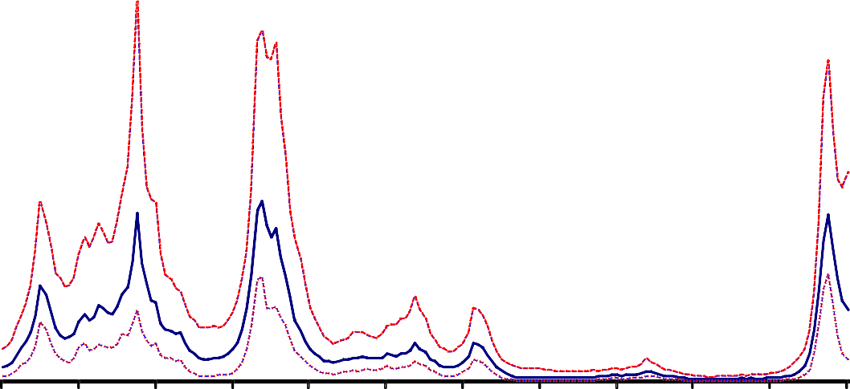

**Macroeconomic Volatility Measures**

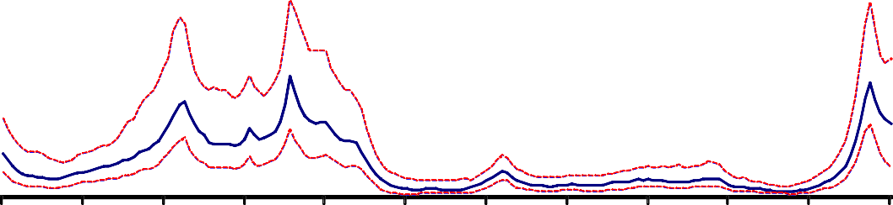

|  |  |  |  |  |  |  |  |  |  |  |
| --- | --- | --- | --- | --- | --- | --- | --- | --- | --- | --- |
| United States |  |  |  |  |  |  |  |  |  |  |
|  |  |  |  |  |  |  |  |  |  | 7 |
|  |  |  |  |  |  |  |  |  |  | 6 |
|  |  |  |  |  |  |  |  |  |  | 5 |
|  |  |  |  |  |  |  |  |  |  | 4 |
|  |  |  |  |  |  |  |  |  |  | 3 |
|  |  |  |  |  |  |  |  |  |  | 2 |
|  |  |  |  |  |  |  |  |  |  | 1 |
|  |  |  |  |  |  |  |  |  |  | 0 |
| 1966 1970 | 1974 | 1978 | 1982 | 1986 | 1990 | 1994 | 1998 | 2002 | 2006 | 2010 |
| United Kingdom |  |  |  |  |  |  |  |  |  |  |
|  |  |  |  |  |  |  |  |  |  | 7 |
|  |  |  |  |  |  |  |  |  |  | 6 |
|  |  |  |  |  |  |  |  |  |  | 5 |
|  |  |  |  |  |  |  |  |  |  | 4 |
|  |  |  |  |  |  |  |  |  |  | 3 |
|  |  |  |  |  |  |  |  |  |  | 2 |
|  |  |  |  |  |  |  |  |  |  | 1 |
|  |  |  |  |  |  |  |  |  |  | 0 |
| 1966 1970 | 1974 | 1978 | 1982 | 1986 | 1990 | 1994 | 1998 | 2002 | 2006 | 2010 |

**CHART 3a**

**Impulse Responses for United States**

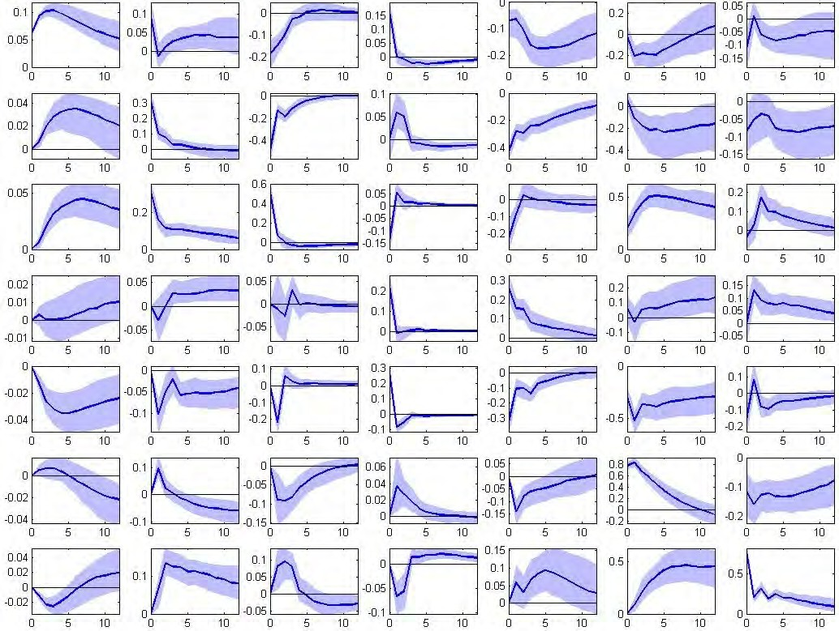

Demand shock

Credit demand shock

Credit supply shock

Monetary policy shock

House price shock

Volatility shock

Supply shock

House

Policy rate price inflation

Change in

bond Real credit

spread growth

GDP

growth

Inflation

Macro- volatility

**United States**

**CHART 3b**

**Impulse Responses for United Kingdom**

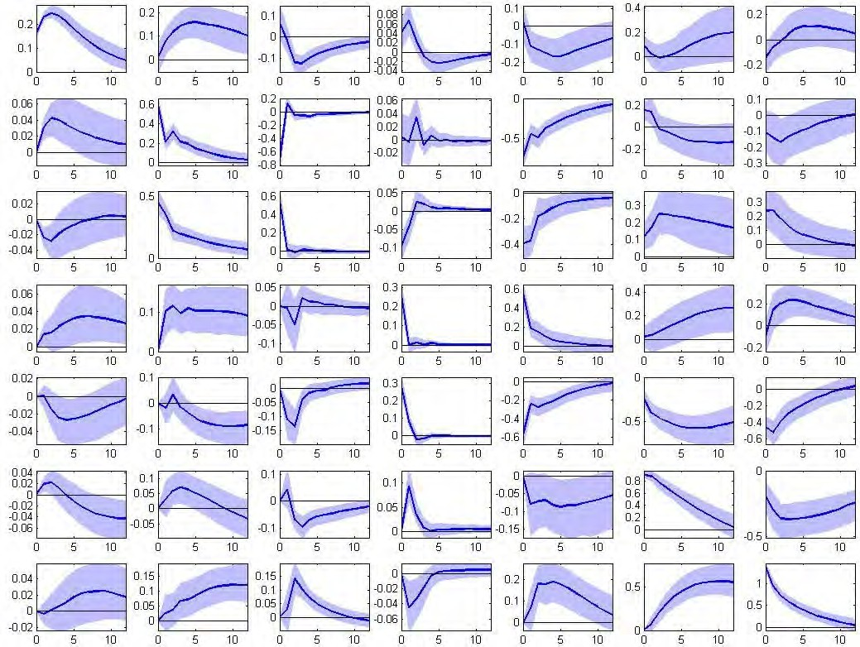

Demand shock

Credit demand shock

Credit supply shock

Monetary policy shock

House price shock

Supply shock

Volatility shock

House

Policy rate price inflation

Change in Real credit bond

spread growth

GDP

growth

Inflation

Macro- volatility

**United Kingdom**

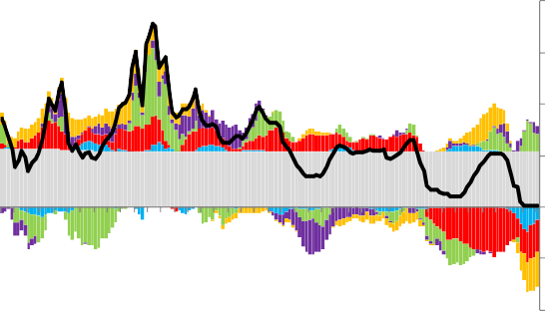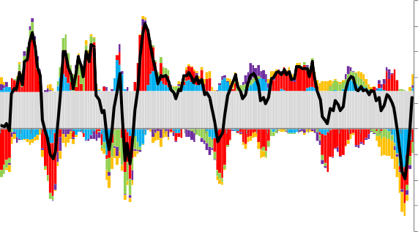**CHART 4a**

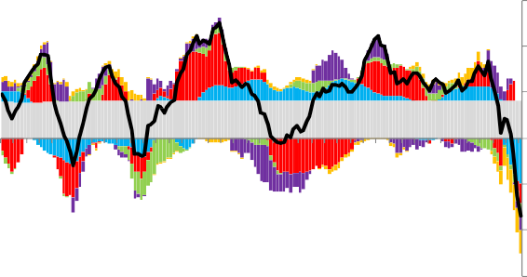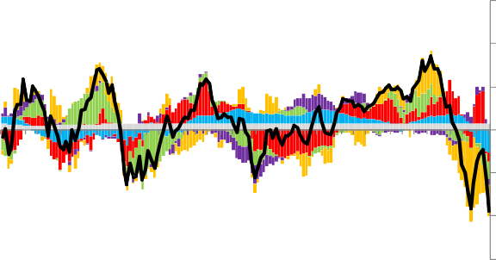**Historical Decompositions: United States**

|  |  |  |  |  |  |  |  |  |  |  |  |  |  |  |  |
| --- | --- | --- | --- | --- | --- | --- | --- | --- | --- | --- | --- | --- | --- | --- | --- |
| **Real credit growth (ann %)** | | | | | | | | | | | **Real house price inflation (ann %)** | | | | |
|  |  | 15 | | | | | | | | | |  |  |  | 15 |
|  |  | 10 | | | | | | | | | |  |  |  | 10 |
|  |  | 5 | | | | | | | | | |  |  |  | 5 |
|  |  | 0 | | | | | | | | | |  |  |  | 0 |
|  |  | ‐5 | | | | | | | | | |  |  |  | ‐5 |
|  |  | ‐10 | | | | | | | | | |  |  |  | ‐10 |
|  |  | ‐15 | | | | | | | | | |  |  |  | ‐15 |
| 1970 | 1974 | 1978 | 1982 | 1986 | 1990 | 1994 | 1998 | 2002 | 2006 | 2010 | 1970 | 1974 | 1978 1982 1986 1990 1994 1998 2002 | 2006 | 2010 |
|  |  | **Federal Funds rate (%)** | | | | | | | | |  |  | **GDP growth (ann %)** |  |  |
|  |  | 20 | | | | | | | | |  |  |  |  | 10 |
|  |  | 15 | | | | | | | | |  |  |  |  | 8 |
|  |  |  | | | | | | | | |  |  |  |  | 6 |
|  |  | 10 | | | | | | | | |  |  |  |  | 4 |
|  |  | 5 | | | | | | | | |  |  |  |  | 2 |
|  |  |  | | | | | | | | |  |  |  |  | 0 |
|  |  | 0 | | | | | | | | |  |  |  |  | ‐2 |
|  |  | ‐5 | | | | | | | | |  |  |  |  | ‐4 |
|  |  |  | | | | | | | | |  |  |  |  | ‐6 |
|  |  | ‐10 | | | | | | | | |  |  |  |  | ‐8 |
| 1970 | 1974 | 1978 1982 1986 1990 1994 1998 2002 2006 2010 | | | | | | | | | 1970 | 1974 | 1978 1982 1986 1990 1994 1998 2002 | 2006 | 2010 |
|  |  | **Legend:15**  Trend  Aggregate demand and supply shocks Credit market shocks | | | | | | | | | |  | Macro volatility shock Monetary policy shock  House price shock |  |  |

15 “Aggregate demand and supply shocks” is the net impact of the aggregate demand shock and the aggregate supply shock. Similarly, “Credit market shocks” is the net impact of the credit demand and credit supply shocks.

### CHART 4b

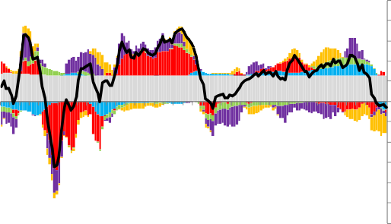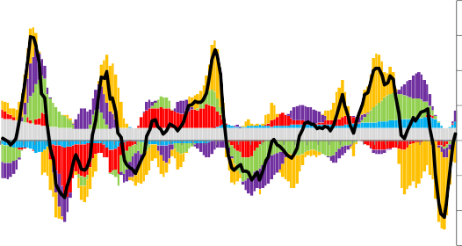**Historical Decompositions: United Kingdom**

|  |  |  |  |  |  |  |  |  |  |  |  |  |  |  |  |  |  |  |  |  |  |
| --- | --- | --- | --- | --- | --- | --- | --- | --- | --- | --- | --- | --- | --- | --- | --- | --- | --- | --- | --- | --- | --- |
| **Real credit growth (ann %)** | | | | | | | | | | | **Real house price inflation (ann %)** | | | | | | | | | | |
| 25 | | | | | | | | | | | 40 | | | | | | | | | | |
| 20 | | | | | | | | | | | 30 | | | | | | | | | | |
| 15 | | | | | | | | | | |  | | | | | | | | | | |
| 10 | | | | | | | | | | | 20 | | | | | | | | | | |
| 5 | | | | | | | | | | | 10 | | | | | | | | | | |
| 0 | | | | | | | | | | |  | | | | | | | | | | |
| ‐5 | | | | | | | | | | | 0 | | | | | | | | | | |
| ‐10 | | | | | | | | | | | ‐10 | | | | | | | | | | |
| ‐15 | | | | | | | | | | |  | | | | | | | | | | |
| ‐20 | | | | | | | | | | | ‐20 | | | | | | | | | | |
| ‐25 | | | | | | | | | | | ‐30 | | | | | | | | | | |
| ‐30 | | | | | | | | | | | 1970 | 1974 | 1978 | 1982 | 1986 | 1990 | 1994 | 1998 | 2002 | 2006 | 2010 |
| 1970 | 1974 | 1978 | 1982 | 1986 | 1990 | 1994 | 1998 | 2002 | 2006 | 2010 |  | | | | | | | | | | |
| **Bank Rate (%)** | | | | | | | | | | | **GDP growth (ann %)** | | | | | | | | | | |
|  |  |  |  |  | 20 | | | | | | |  |  | | | | |  |  |  | 12 |
|  |  |  |  |  | 15 | | | | | | |  |  | | | | |  |  |  |  |
|  |  |  |  |  |  | | | | | | |  |  | | | | |  |  |  | 8 |
|  |  |  |  |  | 10 | | | | | | |  |  | | | | |  |  |  |  |
|  |  |  |  |  | 5 | | | | | | |  |  | | | | |  |  |  | 4 |
|  |  |  |  |  | 0 | | | | | | |  |  | | | | |  |  |  | 0 |
|  |  |  |  |  | ‐5 | | | | | | |  |  | | | | |  |  |  |  |
|  |  |  |  |  |  | | | | | | |  |  | | | | |  |  |  | ‐4 |
|  |  |  |  |  | ‐10 | | | | | | |  |  | | | | |  |  |  |  |
|  |  |  |  |  | ‐15 | | | | | | |  |  | | | | |  |  |  | ‐8 |
| 1970 | 1974 | 1978 | 1982 | 1986 | 1990 | 1994 | 1998 | 2002 | 2006 | 2010 | 1970 | 1974 | 1978 1982 1986 1990 1994 | | | | | 1998 | 2002 | 2006 | 2010 |
|  |  |  |  |  | **Legend:**  Trend  Aggregate demand and supply shocks Credit market shocks | | | | | | |  | Macro volatility shock Monetary policy shock  House price shock | | | | |  |  |  |  |

**CHART 5**

**Central Bank Assets (LHS) and Liabilities (RHS)**

**United States**

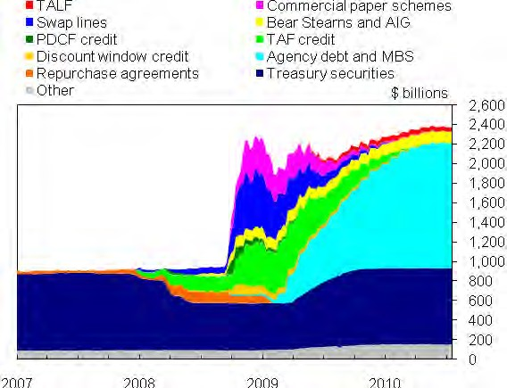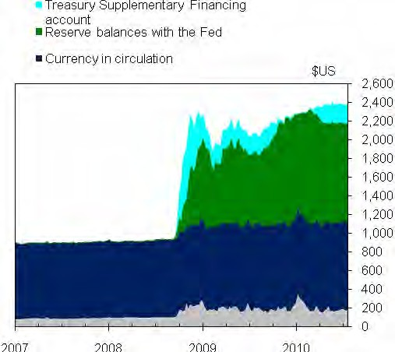

**Euro Area**

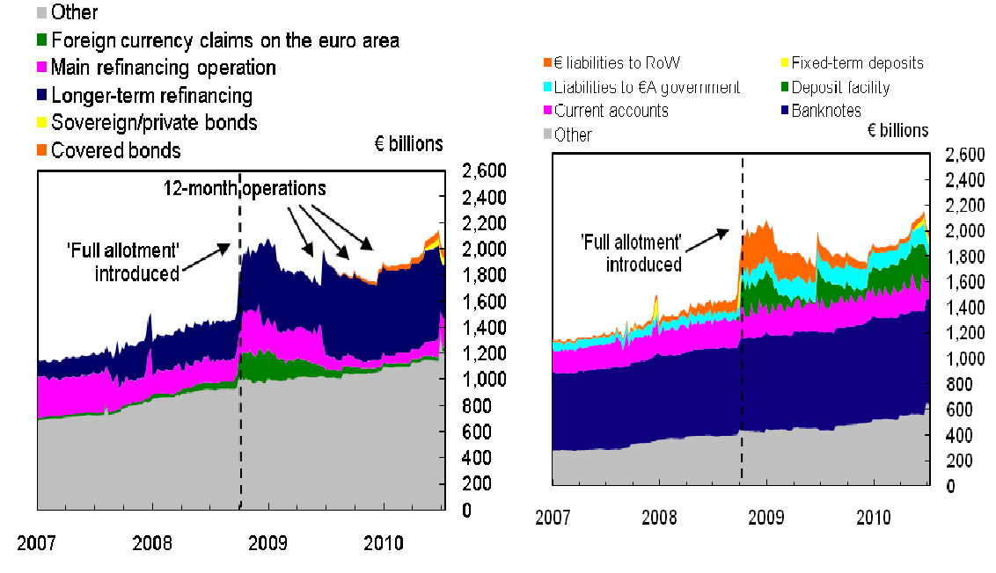

**Chart 5 (cont.)**

**Central Bank Assets (LHS) and Liabilities (RHS)**

**United Kingdom**

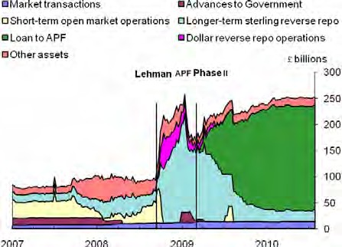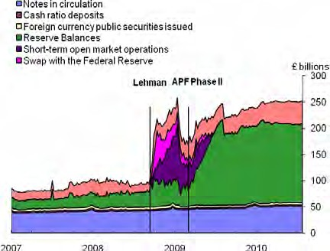

**CHART 6**

**Deviation of Price Level from Deterministic Target Path**



**Deviation of log CPI from trend implied by the inflation target**

Indices (1999 Q1 = 100)

102

Japan USA

Euro Area

UK 101

100

99

98

1992 1994 1996 1998 2000 2002 2004 2006 2008 2010

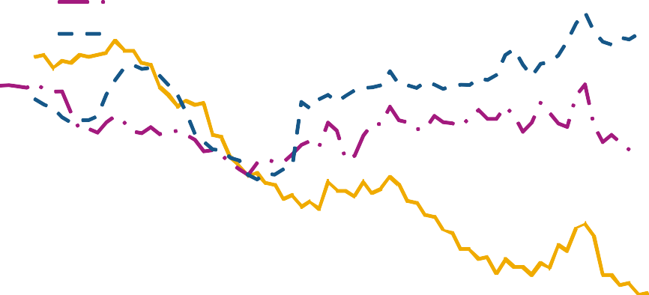

**Deviation of log CPI from trend implied by the inflation target**

Indices (1999 Q1 = 100)

103

New Zealand Sweden

Canada 102

Australia

101

100

99

98

1992 1994 1996 1998 2000 2002 2004 2006 2008 2010

**CHART 7a**

**Simulation of a “Leaning Against The Wind” Policy 2003-6: US**

**Policy rate Real credit growth (ann %)**

10 15

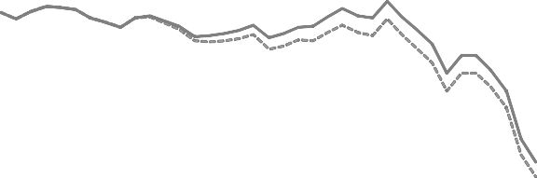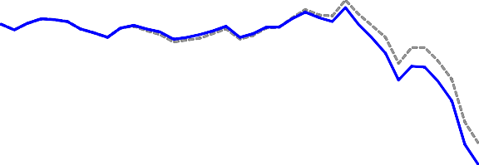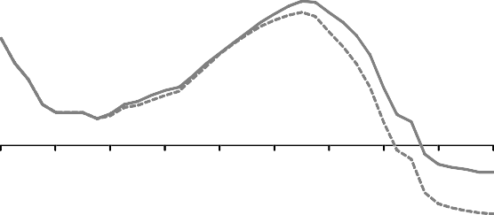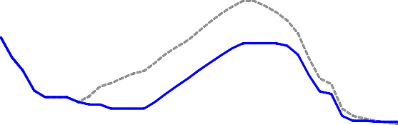

8

10

6

5

4

2

0

-2

-4

-6

2001 2004 2007 2010

0

-5

-10

-15

2001 2004 2007 2010

### Real house price growth (ann %) GDP growth (ann %)

10

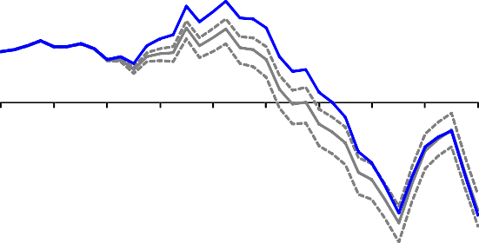

5

0

-5

-10

-15

2001 2004 2007 2010

5

4

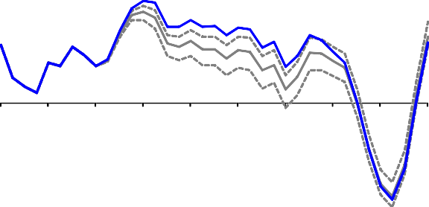

3

2

1

0

-1

-2

-3

-4

-5

2001 2004 2007 2010

### CHART 7b

**Simulation of a “Leaning Against The Wind” Policy 2003-6: UK**

**Policy rate Real credit growth (ann %)**

10

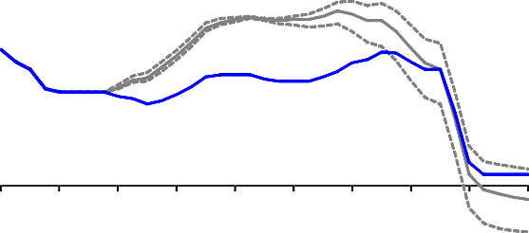

8

6

4

2

0

-2

-4

2001 2004 2007 2010

14

12

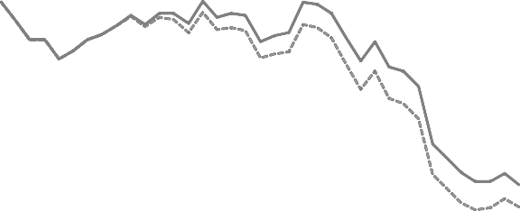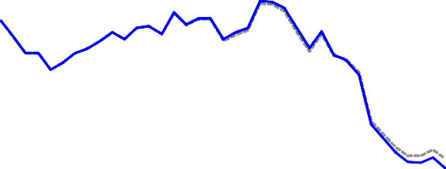

10

8

6

4

2

0

-2

-4

-6

2001 2004 2007 2010

### Real house price growth (ann %) GDP growth (ann %)

30 6

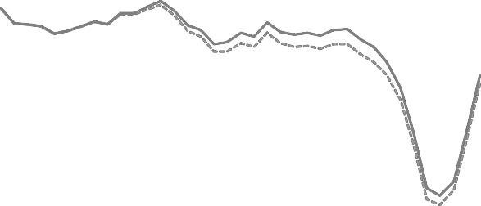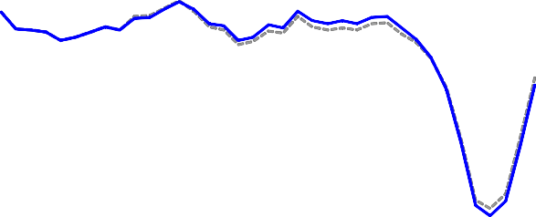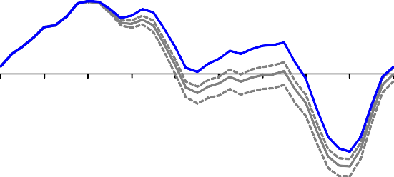

20 4

10 2

0 0

-10 -2

-20 -4

-30 -6

-40

2001 2004 2007 2010

-8

2001 2004 2007 2010

### CHART 8

response to technology shock with commitment

x 10-3 inflation

1

0

。

- 0.02 '

+­ ，

，I

-0.04 ,'

-0.06 ，I

o-utp-ut·-ga-p -· - - -

。

- 0.02

capital gap

＿

-5

5 10 15 20

,

nom na rate

1 2 3

3 0 3

0.5

0-:

-0.5

5 1

sprea8

|  |  |  |  |  |  |  |  |  |  |
| --- | --- | --- | --- | --- | --- | --- | --- | --- | --- |
| ｀I  ｀ | | | | | | | | | |
| I I | - | - | - | - | - | - | - | - | - |

15 20

-0..U0、4 .多. "' 夕

5 10 15 20

bank capital

O· 一一一一一一一一一

·

5 10 15 20

leverage

6 (

5 1? 15 20

price of cap ta

o -

- - - - -

唱 --

5 10 15 20

tax

,，＇

5

0 -

4 -1

｀2 I

0 .

5 10 15 20

- - - - - _- , - -

-0.5

，t －－ -2

— -4

，

5 10 15 20

5 10 15 20

一一一 i nterest rate only

int erest rate and banking sector tax

response to financial sector shock with commitment

0.15

0 .1

inflation

output gap

I.1 .

。

-0.2 、、

--------

capital gap

0.05

，I 夕－－－－－－－－－

1

1

I I

O.

-0.4

-0.6

，'

，

,

11

0 2 4

0 ．0 ．

' －

... ...

... ＿ ＿ ,

.-.＿

5 10 15 20

nom na rate

。，，，I,

3 ｀i

2｀I

5 1

spre g

15 20

10 I:- -

5 10 15 20

bank capital

- - - -

5 10 15 20

一

＇

2＿＿

。1 ，;1..

-1

，·

I

一一一一一一一一一

1＿

5 orice),? cao 115 20

，----

， －－－

O T - - - - - - - - - -

-10 ，I

5 10 15 20

leverage

I

10

price of c-ap-ta·- - - o -

-5

。

tax

｀0 -t - - - - - - - - - -

，，，

1 2

_

## ---

-10

-10｀ 憾．

I - - -

－－－

# —

，

＿＿

5 10 15 20

5 10 15 20

一一一 inte 「 e st rate only

-15

5 10 15 20

inte 「 est rate and banking sector tax

response to markup shock with commitment

0.1 I

｀

0 .0｀5 I

1nfia!lon

output gap capital gap

0.21

0.2 I

。I- 一一一一一一一一 －－

0.4 I

0.6 1.,...－ -

--- ---

...、－－－－－－－－－－

、、

＿ ＿ ＿

0

- -0 . 2

-

o - ',, 一一一一一一一一一 －

5 10 15 20

nom na rate



-0.2 I

-04 :

＇

-

0.2

、

、，一一一一一一一一．

O·

5 1

spreag

15 20

-0.4

:

．＿ ＿ ＿ ＿ ＿＿＿，一一一

5 10 15 20

bank capital

-0 .6 I

.0

，- - - - · - - - - -

。·嘈 11

。

5 10 15 20

leverage

.

-0.2

0.2

5 porice bo?f caop 1ta5l 20

5 10 15 20

tax

-1 。I- 一一一一一 －－-－--－-－

－

-1

-0.2 .

．呻

-2 -0.4 `•k .; ..... -2

—

5 10 15 20 5 10 15 20

5 10 15 20

一一一 i nterest rate only int erest「ate and banking sector tax

### Chart 9

response to markup shock with two instruments: single v separate decision making

x 1 0 -3 inflation output gap capital gap

- - ... ... .. .... .. ..

. 0

15

10

。5

0.1

0. 05

5 nominaaql **rate** 15

-0 . 2

20

... ... ... ... .. ＿ - ..

.- _-

＿

.. - - -

。

尸。

0 . 21

5

－－

一一一．

、

、、

0 2

5 1

。

＿＿＿

spreJS

15 20

，，，

2

。

＿

5 bank 1c0apital 15 20

tax －－

**、** 、、

、..

----

5

。

1 5 0

。

。

- 1

-2 ,

levera10ge

＿

**.**....

憾多

＇， －－

15 20

----

0.｀3 \

0.2

pnce o?captif

｀、 、、

20

- 1 ,

10 15 20

- 3,

5 10 15 20

0.。1

5

蛔 -2

－10 －－1－5 －－20

5 10 15 20

|  |  |  |  |  |
| --- | --- | --- | --- | --- |
| 。 |  | ＿ | ＿ |  |
| \.,  ' | 雪呻 | | | |

- - - discretion with single pol cy maker - discretion with two pol cy makers. 'I,'I,'I,'I,""full commitment